**Real-time Anomaly-Detection in CCTV Footage Using Deep Learning and Alerting System**

***A Project Report submitted***

***in partial fulfillment of the requirements***

***for the award of the degree of***

**BACHELOR OF TECHNOLOGY**

***In***

**COMPUTER SCIENCE & ENGINEERING**

***By***

Karishma Fathima - 21B01A0573

K. Sirisha - 21B01A0574

K. Mona Satwika - 21B01A0584

M. Lakshmi Sowmya - 21B01A0593

O. Dhathri - 21B01A05C6

***Under the esteemed guidance of***

**Dr. P. Kiran Sree**

**Head of Department**

**Department of CSE**



**DEPARTMENT OF COMPUTER SCIENCE & ENGINEERING**

**SHRI VISHNU ENGINEERING COLLEGE FOR WOMEN(A)**

**(Approved by AICTE, accredited by NBA & NAAC, Affiliated to JNTU Kakinada)**

**BHIMAVARAM – 534 202**

**2024 – 202**

**SHRI VISHNU ENGINEERING COLLEGE FOR WOMEN(A)**

**(Approved by AICTE, accredited by NBA & NAAC, Affiliated to JNTU Kakinada)**

**BHIMAVARAM – 534 202**

**DEPARTMENT OF COMPUTER SCIENCE & ENGINEERING**



**CERTIFICATE**

*This is to certify that the project entitled “***Real-time Anomaly-Detection in CCTV Footage Using Deep Learning and Alerting System***”, is being submitted* ***by KarishmaFathima, K.Sirisha, K. Mona Satwika, M. Lakshmi Sowmya, O. Dhathri***

*bearing* *the* ***Regd. No. 21B01A0573, 21B01A0574,******21B05A0584, 21B05A0593, 21B01A05C6*** *in partial fulfillment of the requirements for the award of the degree of “****Bachelor of Technology*** *in* ***Computer Science & Engineering****” is a record of Bonafide work carried out by her under my guidance and supervision during the academic year 2024–2025 and it has been found worthy of acceptance according to the requirements of the university.*

**Internal Guide Head of the Department**

**External Examiner**

**ACKNOWLEDGMENT**

The satisfaction that accompanies the successful completion of any task would be incomplete without the mention of the people who made it possible and whose constant encouragement and guidance have been a source of inspiration throughout the course of this seminar. We take this opportunity to express our gratitude to all those who have helped us in this seminar.

We wish to place our deep sense of gratitude to **Sri. K. V. Vishnu Raju, Chairman of SVES**, for his constant support on each and every progressive work of mine.

We wish to express our sincere thanks to **Dr. G. Srinivasa Rao, Principal of SVECW** for being a source of inspiration and constant encouragement.

We wish to express our sincere thanks to **Dr. P. Venkata Rama Raju, Vice-Principal of SVECW** for being a source of inspiration and constant encouragement.

We wish to express our sincere thanks to **Dr. P. Srinivasa Raju,** our **Director Students Affairs & Admin for SVES Group of Institutions** in Bhimavaram.

We wish to place our deep sense of gratitude to **Dr. P. Kiran Sree, Head of the Department** **of Computer Science & Engineering** for his valuable pieces of advice in completing this seminar successfully.

We are deeply thankful to our project coordinator **Dr. P. R. Sudha Rani, Professor** for her indispensable guidance and unwavering support throughout our project's completion. Her expertise and dedication have been invaluable to our success.

Our deep sense of gratitude and sincere thanks to ***Dr. P. Kiran Sree Head of Department***

***Department of CSE*** for his unflinching devotion and valuable suggestions throughout my project work.

**Project Associates:**

Karishma Fathima - 21B01A0573

K. Sirisha - 21B01A0574

K. Mona Satwika - 21B01A0584

M. Lakshmi Sowmya - 21B01A0593

O. Dhathri - 21B01A05C6

**ABSTRACT**

The project aims to develop an advanced surveillance system that uses video data to classify and detect various activities in real-time. The system's primary goal is to categorize videos into three main types: Normal, Violence, and Weaponized. This classification helps identify critical situations that require immediate attention, thus enhancing public safety and security.

To achieve accurate and reliable detection, the system uses a hybrid deep learning approach. It combines Convolutional Neural Networks (CNN) for spatial feature extraction and Gated Recurrent Units (GRU) for modelling the temporal sequences within the video data. The CNN focuses on extracting spatial features from individual frames, while the GRU handles the time-dependent patterns, recognizing activity sequences over time.

The system is trained on a comprehensive and diverse video dataset that includes various real-world scenarios. This variety ensures that the model remains robust and can accurately classify activities in different environments and contexts. The training data plays a crucial role in helping the system recognize a wide range of possible scenarios, making it versatile and adaptable.

The proposed solution is designed to provide real-time monitoring and alerting, offering enhanced security for public spaces. It leverages deep learning technologies to achieve high classification accuracy and efficiency, ensuring rapid detection and response to potential threats. The project also explores optimization techniques aimed at improving system performance, focusing on practical deployment in real-world surveillance environments.

**Table Of Contents**

**S.No** **Topic** **Page No**

1. Introduction 01 – 03
2. System Analysis 04 - 08

2.1 Existing System

2.2 Proposed System

2.3 Feasibility Study

1. System Requirements Specification 09 - 12

3.1 Software Requirements

3.2 Hardware Requirements

3.3 Functional Requirements

1. System Design 13 - 28

4.1 Introduction

4.2 Data flow diagrams (or) UML Diagrams

4.3 Database Design

4.3.1 ER Diagrams

4.3.2 Table Structure

1. System Implementation 29 - 51

5.1 Introduction

5.2 Project Modules

5.3 Algorithms

5.4 Screens

1. System Testing 52 – 68

6.1 Introduction

6.2 Testing Methods

6.3 Test Cases

1. Conclusion 69 - 70
2. Bibliography 71 - 72
3. Appendix 73 - 78

**List of Figures**

**Figure Page No**

4.2.1 Level 1 Diagram 18

4.2.2 Level 2 Diagram 18

4.2.3 High Level View Diagram 19

4.2.4 UseCase Diagram 20

4.2.5 Class Diagram 21

4.2.6 Collaboration Diagram 22

4.2.7 Deployment Diagram 23

4.2.8 Activity Diagram 23

4.2.9 Component Diagram 24

4.3.1.1 ER Diagram 26

5.2.2.1 Feature Extractor 34

5.2.4.1 Model Training Using GRU 36

5.2.4.2 Model Training Using CNN 39

5.2.5.1 Model Loss and Accuracy of GRU 40

5.2.5.2 Model Loss and Accuracy of CNN 40

5.4.1-6 Web Pages 49-51

1. **INTRODUCTION**

Department of CSE - SVECW | 1

In recent years, surveillance systems have become crucial for ensuring safety and security in public and private spaces. Traditional surveillance methods often rely on human operators who monitor multiple video feeds, making it difficult to detect and respond to threats in real-time. With the rise of video data and advancements in deep learning, there is an opportunity to automate the surveillance process and significantly enhance the efficiency of threat detection.

This project focuses on developing a video surveillance system capable of classifying activities into three distinct categories: Normal, Violence, and Weaponized. The system will leverage deep learning algorithms, specifically Convolutional Neural Networks (CNN) and Gated Recurrent Units (GRU), to process and analyse video data effectively. CNNs will be used for extracting spatial features from individual video frames, while GRUs will analyse temporal patterns, allowing the system to recognize sequences of actions over time.

The system aims to automatically detect and classify activities, providing real-time alerts to security personnel. This will help reduce the need for constant human monitoring, allowing security teams to focus on high-priority tasks. By utilizing a large video dataset for training, the system will be robust enough to handle different environments and diverse scenarios, improving accuracy and reliability.

The use of deep learning techniques will enhance the system's ability to differentiate between normal activities and potential threats, such as violent behaviour or weapon usage. The final goal of this project is to create a practical solution that can be deployed in various surveillance environments, improving security and public safety by enabling quicker responses to potential incidents. This system can be integrated into public spaces, transportation hubs, schools, or any area requiring constant surveillance to detect unusual or dangerous activities.

* 1. **Motivation**

The increasing need for public safety and security has made surveillance systems an essential part of modern society. Current systems often struggle with real-time detection and classification of complex activities. By leveraging deep learning techniques like CNN and GRU, this project aims to enhance the accuracy and efficiency of surveillance systems. The goal is to automatically classify activities into categories such as Normal, Violence, or Weaponized, enabling quicker response times. This innovation can contribute to safer environments, reducing human intervention and improving overall security monitoring.

Department of CSE - SVECW | 2

* 1. **Objective of the Project**

The objective of this project is to develop an intelligent surveillance system that can classify activities in real-time from video footage into three categories: Normal, Violence, and Weaponized. The system aims to use Convolutional Neural Networks (CNN) for effective spatial feature extraction from video frames and Gated Recurrent Units (GRU) to analyze the temporal dynamics of video sequences. By leveraging deep learning algorithms, the project seeks to improve the accuracy and efficiency of activity detection.

* 1. **Scope**

The scope of this project is to design and implement a video-based surveillance system capable of classifying activities into three distinct categories: Normal, Violence, and Weaponized. The system will utilize deep learning algorithms, specifically Convolutional Neural Networks (CNN) for spatial feature extraction and Gated Recurrent Units (GRU) for temporal sequence analysis. This project aims to enhance real-time monitoring capabilities in various environments, such as public spaces and secure facilities. Additionally, the system will be evaluated on a video dataset to ensure its effectiveness and accuracy. The solution will be scalable, adaptable to different video resolutions, and capable of providing timely alerts for potential threats. The project will contribute to improving automated surveillance systems, ensuring quicker threat detection and response times.

Department of CSE - SVECW | 3

1. **System Analysis**

Department of CSE - SVECW | 4

System analysis involves examining the existing challenges, limitations, and potential improvements in a system to create an optimized and efficient solution. System analysis is a crucial phase in the development of any technological solution, as it involves assessing the existing challenges, identifying limitations, and proposing improvements for the system. This project aims to enhance surveillance monitoring by implementing deep learning-based anomaly detection in CCTV footage.

The system classifies activities into three categories: Normal, Violence, and Weaponized, using a combination of Convolutional Neural Networks (CNN) for spatial feature extraction and Gated Recurrent Units (GRU) for temporal sequence analysis. This section details the analysis of the existing system, its limitations, and how the proposed system overcomes these challenges.

**2.1 Existing System**

Traditional surveillance systems rely on manual monitoring by security personnel or use rule-based algorithms to detect specific predefined events. Some advanced systems employ basic machine learning models, but these often lack accuracy and fail in real-time detection of complex activities. The existing methods include:

* Manual Surveillance: Requires continuous human monitoring, which is inefficient and prone to human error.
* Motion-Based Anomaly Detection: Uses basic algorithms to detect sudden movements but lacks context awareness, leading to false positives.
* Predefined Rule-Based Systems: Can only detect specific actions based on predefined rules, making them ineffective for new or unexpected behaviours.
* Basic Machine Learning Approaches: Some systems use Support Vector Machines (SVM) or decision trees but struggle with high-dimensional video data and real-time processing.

**Disadvantages of Existing System**

1. High False Positives & False Negatives – Traditional surveillance systems may struggle to accurately classify complex activities, such as distinguishing between normal behavior and subtle signs of violence or weapon usage, leading to false positives or negatives.
2. Limited Real-time Detection – Existing systems often lack the ability to detect and respond to threats in real-time, relying on delayed analysis or manual intervention, which reduces the effectiveness of immediate threat detection.
3. High Dependency on Human Monitoring – Many systems still require human operators to review video feeds continuously, which is both labor-intensive and prone to errors, especially in high-traffic or large-area surveillance environments.
4. Inability to Adapt to Complex Scenarios – Many systems fail in varying environments (e.g., different lighting conditions, crowded spaces).
5. Limited Use of Advanced Deep Learning – Traditional systems may not fully utilize the potential of advanced deep learning techniques like CNNs and GRUs, which can significantly improve the classification of activities over time and enhance the system's accuracy in detecting dynamic events.

Department of CSE - SVECW | 5

**2.2 Proposed System**

The proposed system aims to enhance video surveillance by utilizing deep learning techniques to classify activities into three categories: Normal, Violence, and Weaponized. The system will employ Convolutional Neural Networks (CNN) for extracting spatial features from individual video frames and Gated Recurrent Units (GRU) to analyses the temporal dynamics of video sequences.

By combining these algorithms, the system can detect and classify complex behaviours in real-time, offering a more accurate and efficient solution than traditional surveillance methods. The system will be trained on a large video dataset, ensuring it is robust across various scenarios and environments. Real-time alerts will be generated for potential threats, reducing the need for constant human monitoring. The system's goal is to improve public safety by enabling faster and more reliable threat detection.

**Key Features of the Proposed System:**

* Deep Learning-Based Classification – Detects critical features in each frame, such as human movement patterns, facial expressions, and weapons. Processes sequential video frames to recognize suspicious behaviour over time.
* Real-Time Threat Detection & Alerts – The system continuously analyzes CCTV footage and categorizes activities as Normal, Violence, or Weaponized. If an anomaly is detected, it triggers real-time alerts for immediate security response.
* Automated and Reduced Human Monitoring – The system minimizes human intervention by autonomously identifying threats and notifying security teams.
* Robust Performance in Diverse Environments – Trained on a large dataset of surveillance videos, ensuring adaptability to various lighting conditions, camera angles, and crowd densities. Capable of detecting anomalies in different indoor and outdoor settings.
* Scalability & Multi-Camera Support – Can handle video streams from multiple CCTV cameras simultaneously. Suitable for large-scale deployments in public places, corporate buildings, and transportation hubs.

This system can detect and classify complex behaviours in real-time, offering a more accurate and efficient solution than traditional surveillance methods.

**Advantages of the Proposed System**

1. Real-Time Threat Detection – The system continuously monitors live CCTV footage and detects threats in real time. By immediately analyzing video frames, it classifies activities as Normal, Violence, or Weaponized. Instant alerts allow security personnel to respond quickly, preventing potential security incidents
2. High Accuracy with Deep Learning – It effectively distinguishes between normal behavior and suspicious activities, reducing false positives and false negatives. This ensures more reliable surveillance and threat identification in dynamic environments.

Department of CSE - SVECW | 6

1. Adaptability to Various Environments – The model is trained on diverse datasets, making it effective across different lighting conditions, camera angles, and crowd densities. It can function in both indoor and outdoor settings, ensuring versatility for various security applications. This adaptability makes it a reliable solution for public spaces, businesses, and critical infrastructure.
2. Scalability for Multi-Camera Setups – Designed for large-scale surveillance, the system can process multiple video streams simultaneously. Whether deployed in small buildings or across city-wide security networks, it efficiently manages vast amounts of video data. This ensures seamless monitoring in airports, shopping malls, and high-security zones.
3. Advanced Alerting System – The system integrates automated alerts through email, SMS, or a centralized security dashboard. Instead of manually checking video footage, security teams receive instant notifications when a threat is detected. This proactive approach reduces response time and enhances security readiness.
4. Faster Decision-Making – With real-time anomaly detection, security teams can make informed decisions quickly. The system processes video sequences rapidly, classifies activities, and provides actionable insights. Faster decision-making prevents potential threats from escalating, ensuring a safer environment.
5. Integration with Existing CCTV Systems – The anomaly detection system is compatible with most existing CCTV infrastructures, eliminating the need for costly hardware upgrades. It can be deployed as software alongside current surveillance setups, enhancing their capabilities. This makes it an affordable and practical security solution.
6. Privacy and Compliance Features – The system is designed with privacy and data protection regulations in mind, such as GDPR and local surveillance laws. Sensitive data is encrypted, and access is restricted to authorized personnel, ensuring ethical surveillance practices. This prevents misuse of video footage and safeguards individual privacy.
7. Continuous Learning & Model Improvement – Using AI-driven learning techniques, the model can continuously improve by training on new datasets. It evolves to detect emerging threats, adapting to changes in criminal behavior or surveillance challenges. This ensures long-term reliability and efficiency in maintaining security.

Department of CSE - SVECW | 7

**2.3 Feasibility Study**

A feasibility study evaluates the viability of the proposed anomaly detection system by analyzing its technical, economic, and operational feasibility. It also considers legal, ethical, and sustainability aspects to ensure successful implementation.

**1. Technical Feasibility**

* The system leverages CNN for spatial feature extraction and GRU for temporal analysis, ensuring accurate detection of anomalies in real-time.
* Python-based frameworks such as TensorFlow and OpenCV enable efficient video processing with minimal computational overhead.
* The system can be deployed using edge computing or cloud-based architectures, reducing latency and enhancing scalability.
* Flask or Django is used for backend implementation, ensuring seamless integration with existing CCTV infrastructure.

**3. Operational Feasibility**

* The system provides a user-friendly dashboard, allowing security teams to monitor and manage alerts efficiently.
* Multi-camera support enables scalability, making it suitable for surveillance in large areas such as malls and airports.
* Automated alerts via email, SMS, or dashboards ensure real-time security responses without constant human supervision.
* The system can operate ensuring continuous surveillance and threat detection without fatigue.

**4. Legal and Ethical Considerations**

* The system complies with privacy regulations such as GDPR and CCPA, ensuring ethical surveillance practices.
* Encrypted data storage prevents unauthorized access to video footage, maintaining data security.
* Role-based access control ensures only authorized personnel can review and manage detected anomalies.

**5. Sustainability and Future Scope**

* Encrypted data storage prevents unauthorized access to video footage, maintaining data security.
* Role-based access control ensures only authorized personnel can review and manage detected anomalies.

Department of CSE - SVECW | 8

**3. System Requirements Specification**

Department of CSE - SVECW | 9

The System Requirements Specification (SRS) defines the essential software, hardware, and functional requirements necessary for the successful implementation, execution, and operation of the system. This ensures that the system operates efficiently, meets user needs, and delivers optimal performance.

**Key Components of SRS:**

1. **System Requirements**
   * Software Requirements:Software requirements include essential tools, platforms, frameworks, and environments for system development and execution.
   * Hardware Requirements:Hardware requirements include processor, RAM, storage, and peripherals for efficient system performance.
   * Functional Requirements: Defines what the system should do,including user interactions, data processing, and system behaviors..
   * Non-functional Requirements: Covers performance, security, reliability, scalability, reliability, and usability standards.
2. **User Requirements**
   * Describe the needs, expectations, and interactions of users to ensure system usability and functionality.
   * Detailed description of each feature with input/output conditions.
3. **Constraints & Assumptions**
   * Lists system limitations, dependencies, and assumptions made during development.

Constraints and assumptions define the system’s boundaries and expected conditions, ensuring feasibility and proper implementation. Constraints include hardware and software limitations, regulatory compliance, budget restrictions, and project timelines. For instance, a system may be required to run only on Windows or Linux, use specific frameworks like TensorFlow, PyTorch, or OpenCV, and meet hardware specifications such as Intel Core i5**,** 16GB RAM, and 512GB SSD to function efficiently. These constraints ensure that the system operates within predefined technical and operational limits..

Assumptions are conditions expected to be true for the system’s proper functionality. They may include stable internet connectivity, sufficient storage, adherence to security protocols like authentication and role-based access control, and availability of APIs for alerting systems. Assumptions also consider the scalability of computational resources if demands increase. Clearly defining constraints and assumptions in the Software Requirements Specification (SRS) document helps in risk management, project planning, and stakeholder alignment, ensuring a smooth development process.

Department of CSE - SVECW | 10

* 1. **Software Requirements**

The software requirements include the operating system, programming languages, frameworks, development tools, and APIs necessary for system functionality**.**

* **Operating System:** Windows or Linux
* **Programming Language:** Python
* **IDE:** Colab,Jupyter or visual studio code
* **Alerting System:** SMTP or API’S
* **Frameworks & Libraries:**

**Tensorflow:**

* + Open-source machine learning framework developed by Google
  + Used for training and deploying deep learning models.
  + Supports neural networks, computer vision, and NLP applications.

**PyTorch**

* + Developed by Facebook, widely used for deep learning research.
  + Preferred for custom model building and rapid prototyping.
  + Provides dynamic computation graphs, making debugging easier.

**Computer Vision Library:**

OpenCV (Open Source Computer Vision Library)

* + Provides tools for image and video processing**.**
  + Supports tasks like object detection, face recognition, and motion tracking.
  + Helps with frame extraction, resizing, and augmentation in video-based applications
  1. **Hardware Requirements**

This section describes the minimum and recommended hardware specifications required to run the system efficiently**.**

**Minimum Requirements:**

* Processor: Intel Core i5 or Higher
* RAM: 16GB
* Storage: 512GB SSD
* Internet Connection:Broadband(Wires or Wi-Fi)

Department of CSE - SVECW | 11

**Recommended Requirements:**

* Processor: Intel Core i5 or Higher
* RAM: 16GB
* Internet Speed: 50+ Mbps Download / 20+ Mbps UploadBroadband
  1. **Functional Requirements**

The functional requirements define the core capabilities and features of the system.

1. **User Authentication & Security**

* Implements secure login with username and password, ensuring restricted access to the system.
* Detects and prevents unauthorized access attempts using logging and anomaly detection.

1. **File Handling & Data Extraction**

* supports importing, storing, and retrieving video files for processing and analysis.
* Extracts frames from video footage using OpenCV for deep learning model input.
* Handles large datasets efficiently using optimized data structures and storage methods.

1. **Real-Time Anomaly Detection & Alerts**

* Continuously monitors video footage for anomalies using deep learning models (TensorFlow/PyTorch).
* Provides a logging mechanism to store and review detected anomalies.
* Generates and sends real-time alerts via SMTP or API when unusual activity is detected.

1. **Model Training & Inference:**

* Supports training deep learning models using TensorFlow/PyTorch for anomaly detection.
* Performs inference in real-time to classify and detect anomalies in video frames.
* Optimizes model performance using GPU acceleration and batch processing techniques.

1. **Web Application Interface**

* Provides a responsive and user-friendly web interface for managing and viewing detections.
* Supports real-time visualization of anomaly detection results and alert notifications.

Department of CSE - SVECW | 12

1. **System Design**

Department of CSE - SVECW | 13

System design is a crucial phase in software development, where the overall architecture, data flow, and interactions between system components are defined. It serves as a blueprint for developers, ensuring that the system is scalable, efficient, and meets the required functionality. This phase involves structural and behavioural design, incorporating various diagrams and methodologies to create a well-organized system.

**Importance of System Design**

* Ensures the scalability of the software to handle increased loads.
* Defines a clear structure for development, reducing complexity.
* Enhances efficiency and performance by optimizing data flow.
* Helps in identifying and mitigating risks before implementation.
* Facilitates collaboration between developers, designers, and stakeholders.

**Components of System Design**

System design consists of two key aspects:

1. High-Level Design (HLD) – Provides a broad overview of the system, including architecture, main modules, and their interactions.
2. Low-Level Design (LLD) – Focuses on the detailed implementation of each module, including class structures, algorithms, and data handling.

**Key Elements of System Design**

1. Architectural Design – Defines the overall system structure, including hardware and software interactions.
2. Data Flow Design – Illustrates how data moves through the system, ensuring smooth processing and storage.
3. User Interface Design – Determines how users interact with the system, ensuring ease of use.
4. Database Design – Structures how data is stored, accessed, and managed within the system.
5. Security Design – Ensures data protection, user authentication, and system integrity.

**Approach to System Design**

A well-structured system design follows an iterative approach, where feedback and improvements are continuously integrated. The process generally involves:

* Requirement Analysis – Understanding user needs and technical constraints.
* Conceptual Design – Creating UML diagrams like use case, class, and sequence diagrams.
* Implementation Planning – Defining technical specifications, tools, and frameworks to be used.
* Testing and Validation – Ensuring the design meets performance and security benchmarks.

Department of CSE - SVECW | 14

Relevance to the Anomaly Detection in CCTV Footage using Deep Learning and with Alerting System.

The architecture of the Anomaly Detection in CCTV Footage using Deep Learning and with Alerting System is divided into the following key Modules:

* Video Data Collection and Data Preprocessing
* Activity Detection and Classification (Normal, Weaponized and Violence).
* Real-Time Monitoring and Alert Generation using email.
* Performance Optimization
* User Interface and Visualization

**4.1 Introduction**

Software design is a fundamental phase in software development that focuses on defining the architecture, components, data flow, and database structure of the system. It helps in visualizing how different modules interact and ensures that the implementation meets functional and non-functional requirements efficiently.

The Anomaly Detection in CCTV Footage system is an AI-powered surveillance solution designed to enhance security by automatically detecting suspicious activities in real-time. It leverages Convolutional Neural Networks (CNNs) and Inception V4 for feature extraction from CCTV footage, while Gated Recurrent Units (GRUs) analyze temporal patterns to identify violent or anomalous behavior. The model is trained on Smart-City CCTV Violence Detection Datasetto ensure high accuracy in recognizing potential threats.

The primary goal of the system design is to create a seamless, intelligent, and user-friendly platform that integrates deep learning models for processing CCTV footage. The System minimizes reliance on manual surveillance, improving response time and safety in public areas by providing an automated, intelligent security monitoring solution.

* Real-Time Anomaly Detection – Utilizes Inception V4 and CNN to extract spatial features from CCTV footage, enabling instant identification of violent activities or suspicious behavior.
* Temporal Activity Analysis with GRU – Implements Gated Recurrent Units (GRUs) to analyze sequential video frames, capturing temporal dependencies in motion patterns and detecting continuous anomalies.
* Pretrained ImageNet Model – Uses ImageNet-trained Inception V4 to enhance feature extraction, ensuring high accuracy in detecting various violent actions in diverse environments.
* Automated Alert System with Image Capture – Upon detecting an anomaly, the system captures the relevant frame and sends an alert via email to security personnel, including the image as evidence for quick response.
* User-Friendly Interface – Developed using Flask and Python, ensuring a simple and interactive user experience.
* Secure and Efficient Data Handling – Optimized database design for storing, retrieving, and managing login details.

Department of CSE - SVECW | 15

**System Design Approach**

The system design follows a structured and modular approach to ensure real-time processing, scalability, and efficiency in detecting anomalies in CCTV footage.

1. Data Collection and Preprocessing –Videos are segmented into frames, resized to 224x224, and normalized for consistency.
2. Deep Learning Model Integration –

* CNN (Inception V4) is used for feature extraction from video frames.
* GRU (Gated Recurrent Units) handles temporal pattern recognition, capturing motion over time.

1. The model is pretrained on ImageNet, leveraging high-quality feature embeddings
2. Anomaly Detection and Alerting System– The trained model classifies frames into Normal, Violence, or Weaponized activities. If an anomaly (Violence/Weaponized) is detected:
   * + - The system captures the specific frame.
       - An automated alert is triggered via email.
3. Frontend and Backend Development – The Flask-based UI interacts with backend processing modules, ensuring a smooth workflow.

**Benefits of the System Design**

### Processes video footage efficiently from the Smart-City CCTV Violence Detection Dataset for anomaly detection.

### Enhances detection accuracy using Inception V4, CNN, and GRU models.

### Automatically captures anomaly frames and sends alerts to security personnel via email.

### Stores detected anomalies (timestamp, location, image) in a MySQL database for future analysis.

### Optimizes feature extraction using pretrained ImageNet weights for improved recognition.

### ****4.2 Data Flow Diagrams (DFD) / UML Diagrams****

To better understand how data moves through the system, **Data Flow Diagrams (DFDs) or UML diagrams** represent different components and their interactions.

**Data Flow Diagram:**

A Data Flow Diagram (DFD) is a graphical representation of how data moves through a system. It shows the flow of information between external entities, processes, and data stores without focusing on the technical details of implementation.

Department of CSE - SVECW | 16

**Types of Data Flow Diagrams (DFDs)**

A Data Flow Diagram (DFD) visually represents how data moves through a system, showcasing its inputs, processes, and outputs. There are two main types of DFDs:

**1. Logical Data Flow Diagram**

* Focuses on what the system does rather than how it is implemented.
* Shows the flow of data independent of system architecture or technology.
* Helps in understanding business processes before designing a system.
* Example: A logical DFD for a Anomaly Detection system might show how videos are processed and divided into frames and sizing, without detailing specific algorithms or software used.

**2. Physical Data Flow Diagram**

* Represents how the system is implemented, including hardware, software, and database structures.
* Shows system components like servers, databases, file storage, and user interfaces.
* Helps developers understand the technical implementation of the system.
* Example: A physical DFD for a Anomaly detection system might show how CNN models, RNN models, and the database interact to process and classify the videos.

**Levels of Data Flow Diagrams**

DFDs are often created in hierarchical levels to provide increasing detail about the system:

1. **Level 0 DFD (Context Diagram)**
   * The highest-level diagram, showing the entire system as a single process.
   * Displays how external entities (users, other systems) interact with the system.
   * Example: Shows users uploading videos and receiving classification of videos.
2. **Level 1 DFD**
   * Expands the main process into multiple sub-processes, detailing the primary functions.
   * Example: Breaking down System into preprocessing ,model training and model testing .
3. **Level 2 DFD and Beyond**
   * Further breaks down each process from Level 1 into detailed sub-processes.
   * Example: "Model Training" might be broken into Feature Extraction, Model Selection and Accuracy Checking.

**Importance of DFDs**

* Simplifies complex systems by visualizing data movement.
* Identifies inefficiencies and bottlenecks.
* Improves communication between stakeholders.
* Helps in system documentation and design.

**Contrast Level**

Department of CSE - SVECW | 17

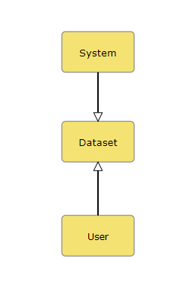

*Fig 4.2.1:Level 1 Diagram*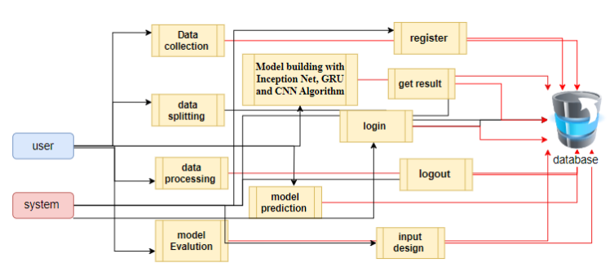

*Fig 4.2.2:Level 2 Diagram*

Department of CSE - SVECW | 18

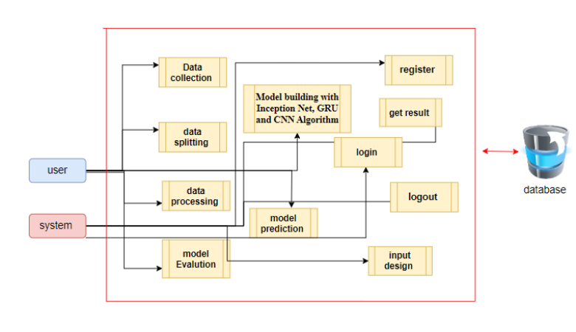

*Fig 4.2.3 : High level view diagram*

**UML Diagram:**

A UML (Unified Modelling Language) diagram is a visual representation of a system that helps in designing, analysing, and documenting software architectures. UML is widely used in software engineering to model the structure and behaviour of systems.

**Types of UML Diagrams**

UML diagrams are broadly categorized into Structural Diagrams and Behavioural Diagrams:

**1. Structural Diagrams (Represent Static Aspects)**

* Class Diagram: Shows classes, attributes, methods, and relationships (inheritance, association, etc.).
* Object Diagram: Represents instances of classes and their relationships at a specific moment.
* Component Diagram: Displays how different components of a system interact.
* Deployment Diagram: Illustrates the physical deployment of artifacts on nodes (e.g., servers).
* Package Diagram: Organizes classes into packages.
* Composite Structure Diagram: Represents the internal structure of a class.

**2. Behavioural Diagrams (Represent Dynamic Aspects)**

* Use Case Diagram: Shows user interactions with the system.
* Sequence Diagram: Represents object interactions over time.
* Activity Diagram: Illustrates workflows and processes.
* State Diagram: Depicts states and transitions of an object.

Department of CSE - SVECW | 19

* Timing Diagram: Shows time-based changes in an object.

**Uses of UML Diagrams**

* Helps in designing complex systems.
* Improves communication between developers and stakeholders.
* Aids in documentation and maintenance.
* Supports different software development methodologies (Agile, Waterfall, etc.).

**Different Types of UML Diagrams:**

**Use Case Diagram**

* A use-case diagram in the Unified Modeling Language (UML) is a type of behavioral diagram defined by and created from a Use-case analysis.
* Its purpose is to present a graphical overview of the functionality provided by a system in terms of actors, their goals (represented as use cases), and any dependencies between those use cases.
* The main purpose of a use case diagram is to show what system functions are performed for which actor. The roles of the actors in the system can be depicted.

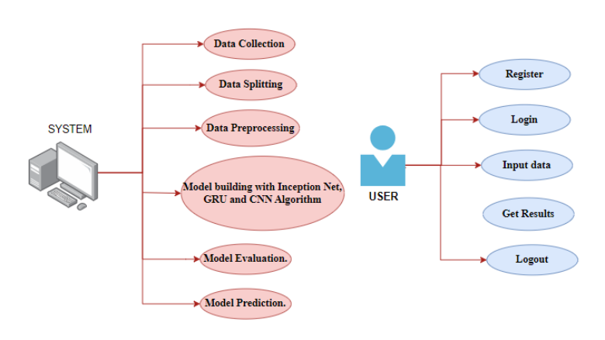

*Fig 4.2.4 : UseCase diagram*

**Class Diagram**

In software engineering, a class diagram in the Unified Modeling Language (UML) is a type of static structure diagram that describes the structure of a system by showing the system's classes, attributes, operations (or methods), and the relationships among the classes. It explains which class contains information.

Department of CSE - SVECW | 20

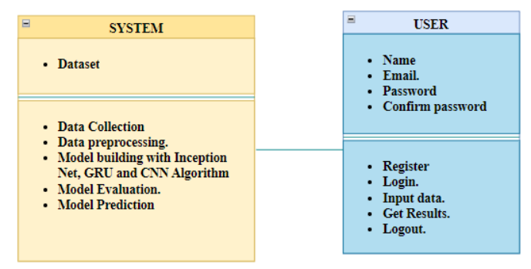

*Fig 4.2.5: Class Diagram*

**Sequence Diagram**

* A sequence diagram in Unified Modeling Language (UML) is a kind of interaction diagram that shows how processes operate with one another and in what order.
* It Is a Construct of A Message Sequence Chart. Sequence Diagrams Are Sometimes called event diagrams, event scenarios, and timing diagrams.

Department of CSE - SVECW | 21

**Collaboration Diagram**

A collaboration diagram (also known as a communication diagram) is a type of behavioural UML diagram that visually represents the interactions between objects in a system. It emphasizes how objects communicate with each other to achieve a specific functionality, showing their relationships and the sequence of messages exchanged. Unlike sequence diagrams, which focus on the time-ordering of messages, a collaboration diagram highlights the structural organization of interacting objects.

The main components of a collaboration diagram include objects (or instances), links (connections between objects), and messages (communication between objects). Each object is represented as a rectangle with its name, and links (lines) between them depict their association. Messages are labelled with numbers to indicate their sequence, making it easy to understand the order of interactions.

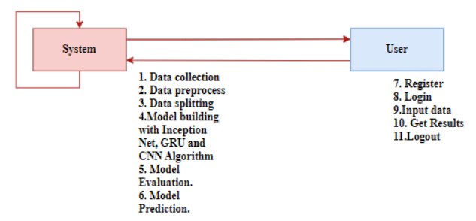

*Fig 4.2.6: Colloboration Diagram*

**Deployment Diagram**

The deployment diagram represents the deployment view of a system. It is related to the component diagram. Because the components are deployed using the deployment diagrams. A deployment diagram consists of nodes. Nodes are nothing but physical hardware’s used to deploy the application.

Department of CSE - SVECW | 22

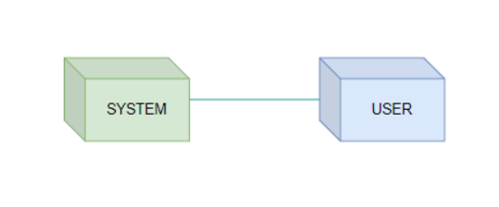  
 *Fig 4.2.7:Deployement Diagram*

**Activity Diagram**

Activity diagrams are graphical representations of workflows of stepwise activities and actions with support for choice, iteration, and concurrency. In the Unified Modelling Language, activity diagrams can be used to describe the business and operational step-by-step workflows of components in a system. An activity diagram shows the overall flow of control.

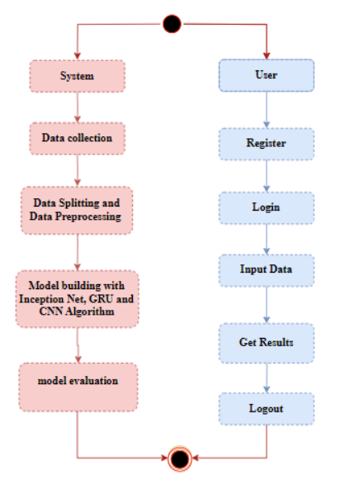  
  
  *Fig 4.2.8:Activity Diagram*

Department of CSE - SVECW | 23

**Component Diagram**

A component diagram, also known as a UML component diagram, describes the organization and wiring of the physical **c**omponents in a system. Component diagrams are often drawn to help model implementation details and double-check that every aspect of the system's required function is covered by planned development.

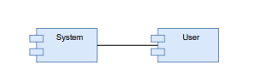  
  *Fig 4.2.9:Component Diagram*

**4.3 Database Design**

Database design is the process of structuring and organizing data within a database to ensure efficient storage, retrieval, and management of information. It involves defining tables, relationships, constraints, and indexes to optimize data integrity and system performance. A well-designed database minimizes redundancy, ensures data consistency, and supports scalability.

**Key Components of Database Design:**

1. Conceptual Design – Defines the high-level structure using Entity-Relationship (ER) diagrams to represent entities, attributes, and relationships.
2. Logical Design – Converts the ER model into a relational schema with tables, primary keys, foreign keys, and normalization.
3. Physical Design – Specifies the actual storage structure, indexing methods, and query optimization for performance enhancement.

**4.3.1 ER Diagrams**

An ER (Entity-Relationship) diagram is a type of data model used to visually represent the relationships between different entities in a system. It is widely used in database design to structure data before implementation in relational databases. ER diagrams help in understanding how data is stored, linked, and managed.

**Components of an ER Diagram**

1. Entities: Represent objects or concepts (e.g., "Student", "Doctor", "Order").
2. Attributes: Properties of an entity (e.g., "Student Name", "Doctor ID").
3. Primary Key: A unique identifier for an entity (e.g., "Student ID").
4. Relationships: Connections between entities (e.g., "Patient books an Appointment").

Department of CSE - SVECW | 24

An ER diagram shows the relationship among entity sets. An entity set is a group of similar entities and these entities can have attributes. In terms of DBMS, an entity is a table or attribute of a table in the database, so by showing the relationship among tables and their attributes, the ER diagram shows the complete logical structure of a database. Let’s have a look at a simple ER diagram to understand this concept.

An Entity-Relationship (ER) Diagram is a visual representation of a system's data and relationships between different entities. For a Deep Learning Note-Taking App that processes handwritten and voice notes using CNN (Convolutional Neural Networks) and NLP (Natural Language Processing), the ER diagram will help understand:

* Entities (e.g., Users, CCTV Cameras, Anomalies, Alerts)
* Relationships (e.g., Cameras capture footage, Anomalies trigger Alerts)
* Attributes (e.g., User name, email, Anomaly Type, Timestamp)

**Key Entities and Relationships**

Based on the provided database schema and application code, the following entities and their relationships can be identified:

1. Users
   * Attributes: User id, Name, Email, Role (Admin/Security), Password.
   * Relationships: Can upload videos and receive alerts.
2. Anomalies
   * Attributes Anomaly id ,Video name, Type (Violence/Weaponized/Normal), Confidence Score, Timestamp
   * Relationships: Detected from CCTV footage.
3. Video
   * Attributes: video id, directories (testing and training), file type (mp4/mov/mkv)
   * Relationships: Frames of detected anomalies.
4. Alert System
   * Attributes: Alert id, Anomaly id, sent (Email), Timestamp, Status (Sent/Not Sent).
   * Relationships: Triggered when an anomaly is detected, sending notifications to security personnel.

**ER Diagram Representation for Anomaly Detection in CCTV Footage using Deep Learning and with Alerting System**

The ER Diagram will consist of:

* Entities (Users, Anomalies, Video, Alert System)
* Relationships (One system can interact with multiple users, The system collects and processes multiple CCTV video feeds)
* Attributes (ID, Name, Email, File Path etc.)

**Relationships Explained**

* One User → Multiple Uploads (1:N Relationship)
* One Video → One Category (1:1 Relationship)
* One Upload→ One Result (Weaponized or Violence or Normal) (1:1 Relationship)
* One Footage → Many Category(N:1 Relationship)

**ER Diagram Notation**

* Rectangle = Entities (System, User)

Department of CSE - SVECW | 25

* Oval = Attributes (Data Collection, Model Training, Register, Login, etc.)
* Diamond = Relationships (e.g., Uploads, Stores, Process

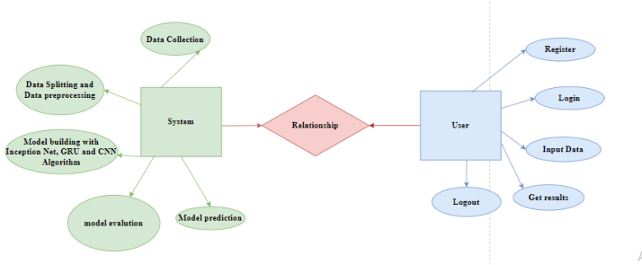 *Fig 4.3.1.1 : ER Diagram*

**4.3.2 Table Structures**

A table structure in a relational database defines how data is stored and organized within a table. It consists of columns (fields), data types, constraints, and relationships that determine how data is managed and maintained.

**Components of a Table Structure**

**A. Columns (Fields)**

* Each column represents a specific attribute of the data stored in the table.
* Example: In a user's table, columns could be id, name, email, and password.

**B. Data Types**

* Defines the type of data that can be stored in a column.
* Common SQL data types:
  + INT → Stores integers (e.g., user ID).
  + VARCHAR(n) → Stores variable-length text (e.g., name, email).
  + TEXT → Stores large text (e.g., descriptions, comments).
  + DATE / DATETIME → Stores dates and timestamps.
  + BOOLEAN → Stores TRUE or FALSE values.

**C. Constraints**

* Rules that ensure data integrity.
* Common constraints:
  + PRIMARY KEY → Ensures uniqueness of each row.
  + FOREIGN KEY → Links data from another table.
  + UNIQUE → Ensures no duplicate values.
  + NOT NULL → Prevents empty values.
  + CHECK → Restricts values based on conditions.

Department of CSE - SVECW | 26

**D. Relationships**

* Defines how tables are connected.
* Types of relationships:
  + One-to-One (1:1) → Each record in Table A is linked to one record in Table B.
  + One-to-Many (1:M) → One record in Table A is linked to multiple records in Table B.
  + Many-to-Many (M: M) → Multiple records in Table A are linked to multiple records in Table B (handled via a junction table).

**Table Structure For Anomaly Detection in CCTV Footage using Deep Learning and with Alerting System.**

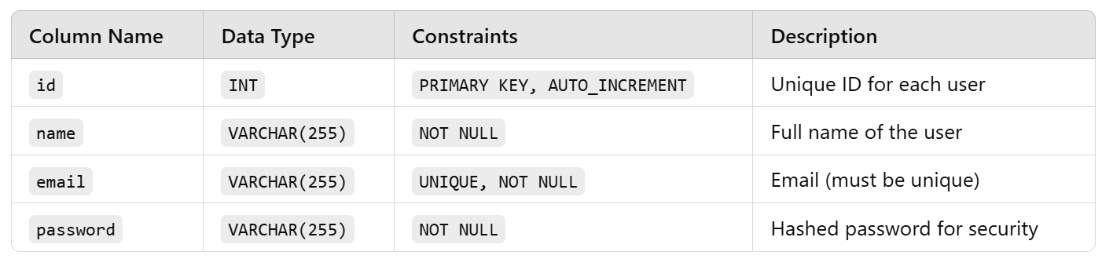

**Table Schema in SQL**

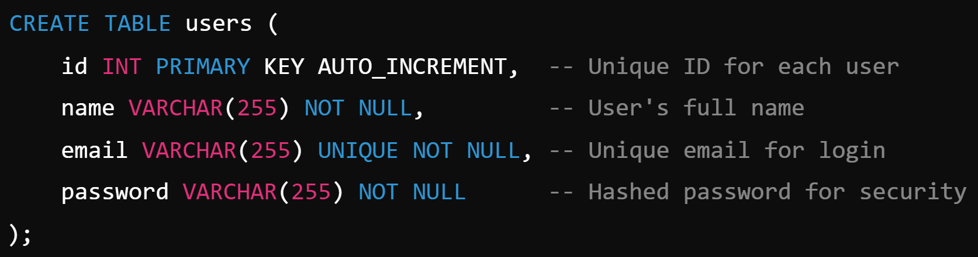

Department of CSE - SVECW | 27

**Importance of Table Structure**

* Ensures Data Consistency – Prevents duplication and maintains relationships.
* Improves Query Performance – Well-structured tables optimize searches and joins.
* Enhances Security – Constraints like NOT NULL and UNIQUE prevent bad data entry.
* Facilitates Data Relationships – FOREIGN KEY constraints link related tables efficiently.

Department of CSE - SVECW | 28

**5. System Implementation**

Department of CSE - SVECW | 29

System Implementation is the process of deploying and integrating a designed system into a real-world environment, ensuring it functions as intended. It involves installing, testing, and making the system operational for end-users.

**Key Steps in System Implementation**

1. Planning and Preparation
   * Define implementation objectives.
   * Allocate resources (hardware, software, team members).
   * Establish a timeline and risk assessment plan.
2. Installation and Configuration
   * Deploy software on servers or cloud platforms.
   * Configure system settings based on project requirements.
   * Set up databases, APIs, and authentication mechanisms.
3. Data Migration
   * Transfer data from old systems to the new system.
   * Ensure data integrity and compatibility.
   * Backup existing data to prevent loss.
4. Testing and Debugging
   * Perform functional and non-functional testing (unit testing, integration testing, system testing).
   * Identify and fix bugs or performance issues.
   * Conduct security testing to prevent vulnerabilities.
5. User Training and Documentation
   * Train users (students, educators, researchers) on system usage.
   * Provide user manuals, tutorials, and FAQs.
   * Offer technical support for troubleshooting.
6. Deployment and Monitoring
   * Roll out the system in phases (pilot testing, full deployment).
   * Monitor system performance and user feedback.
   * Optimize based on real-world usage and user needs.

**System Implementation for the Deep Learning Anomaly Detection n CCTV Footage**

For a Deep Learning Anomaly Detection using CNN and GRU, implementation includes:

* Deploying the AI models (CNN(InceptionV4) for Feature Extraction, GRU for Model Training).
* Setting up data processing pipelines for real-time Anomaly Detection.
* Integrating the SMTP to enable Alerting by Emails.
* Hosting the application on Server with Flask for user access.
* Ensuring the system supports multiple video formats (mp4, avi, mkv).

Department of CSE - SVECW | 30

By following these steps, the system becomes a fully functional, user-friendly platform for digital note management.

**5.1 Introduction**

In today's world, ensuring public safety has become more critical than ever, with surveillance systems playing a vital role in monitoring and preventing security threats. Traditional CCTV surveillance relies heavily on human operators to manually observe multiple video feeds, which can be exhausting, inefficient, and prone to human error.

As the volume of surveillance footage continues to grow, there is a pressing need for automated systems that can detect and classify suspicious activities in real-time. This project aims to develop an AI-powered anomaly detection system for CCTV surveillance, capable of identifying threats and enhancing security measures with minimal human intervention.

The proposed system will utilize deep learning techniques, specifically Convolutional Neural Networks (CNNs) and Gated Recurrent Units (GRUs), to analyse video footage and classify activities into three categories: Normal, Violence, and Weaponized.

CNNs will extract spatial features from video frames, identifying visual patterns that indicate potential threats. Meanwhile, GRUs will process temporal patterns, allowing the system to recognize sequential behaviours and detect anomalies based on movement and activity transitions. By combining these two approaches, the system will be able to accurately differentiate between everyday activities and security threats such as fights, assaults, or the presence of weapons.

One of the key objectives of this project is to enable real-time threat detection and alert generation. Once an anomaly is detected, the system will immediately notify security personnel, allowing them to take swift action. This significantly reduces response times and minimizes the risk of incidents escalating unnoticed.

The system will be trained on a large, diverse video dataset, ensuring robustness across different environments, lighting conditions, and camera angles, making it adaptable to real-world surveillance scenarios. Beyond improving security, this automated surveillance system also helps optimize resource allocation by reducing the need for constant human monitoring.

Security personnel can focus on high-priority situations rather than passively watching surveillance feeds. This makes the system highly valuable for deployment in public spaces, transportation hubs, shopping malls, schools, corporate offices, and other high-security areas where continuous monitoring is necessary.

In conclusion, this project aims to revolutionize traditional surveillance by integrating AI-driven anomaly detection into CCTV systems. By leveraging deep learning models, it will enhance the efficiency, accuracy, and responsiveness of security monitoring. The ability to detect and classify anomalies in real time makes this system a powerful tool in preventing crimes and ensuring public safety. As AI and machine learning technologies continue to evolve, the future of surveillance will rely more on intelligent, automated solutions that can proactively identify threats and protect communities.

Department of CSE - SVECW | 31

**5.2 Project Modules**

The system is divided into five key modules, each serving a specialized function:

**1. User Authentication Module**

* Manages user registration and login securely.
* Uses MySQL to store user credentials.

**2. Video Upload Module**

* Allows users to upload videos in formats like MP4, AVI, MOV, and MKV.
* Stores uploaded videos in a designated directory.
* Processes video frames for anomaly detection.

**3. Video Anomaly Classification Module**

* Loads and preprocesses video frames using OpenCV.
* Uses a pre-trained GRU-based deep learning model for anomaly detection.
* Extracts features using InceptionV3 and classifies videos into normal or anomalous.

**4. Alert Notification Module**

* Sends email alerts to administrators if an anomaly is detected.
* Captures and attaches snapshots of anomaly frames to emails.
* Uses SMTP for secure email communication.

**5. Alarm System Module**

* Triggers an alarm sound when an anomaly is detected.
* Enhances real-time alert mechanisms to notify users.
* Integrates with the anomaly detection module to activate alerts automatically.

Department of CSE - SVECW | 32

**5.2.1: Video Data Preprocessing and Data Preparation Module**

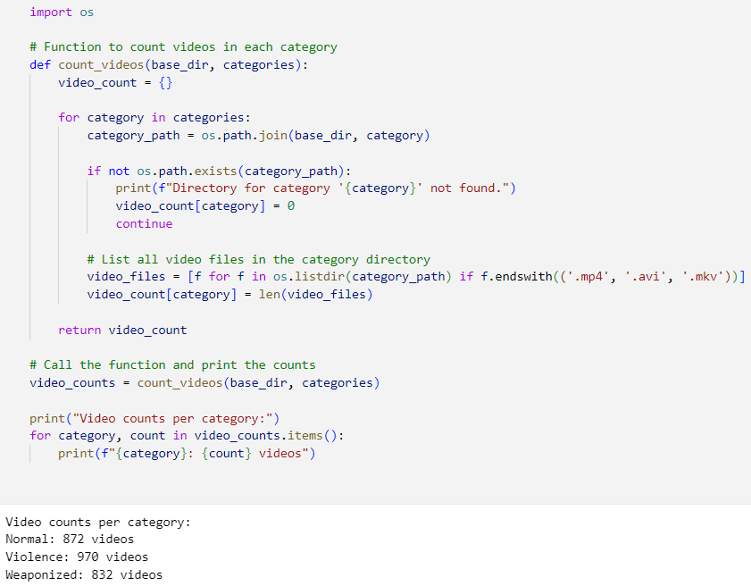

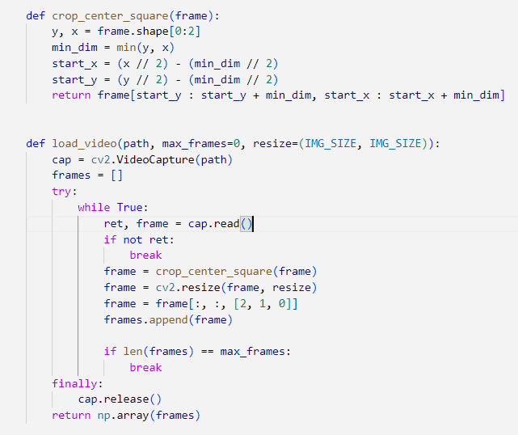

Department of CSE - SVECW | 33

**5.2.2 Feature Extraction from Video frames**

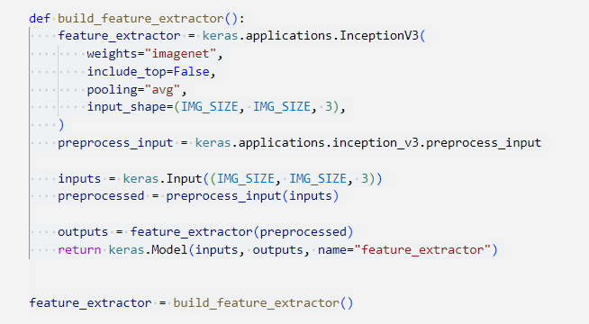 *Fig 5.2.2.1:Feature Extractor using Transfer Learning*

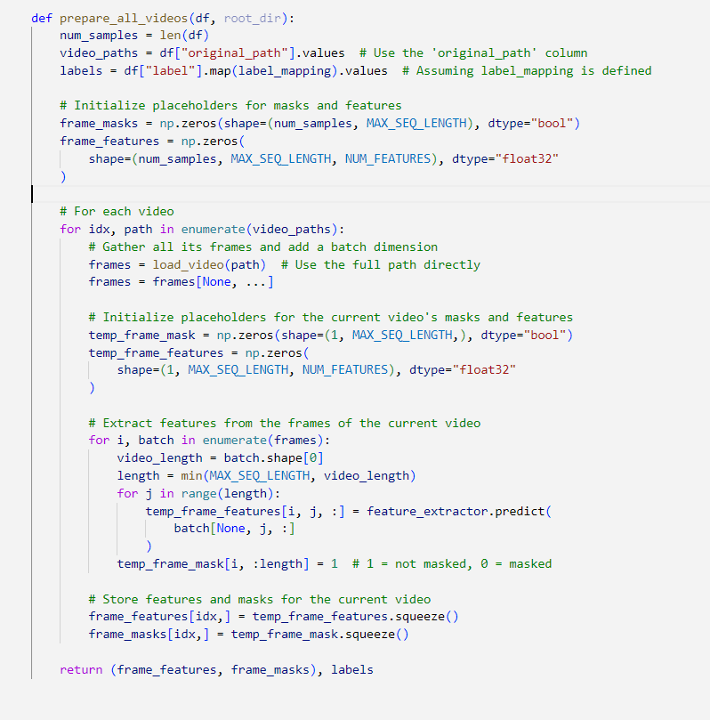

Department of CSE - SVECW | 34

**5.2.3: Splitting Data into Training and Testing**

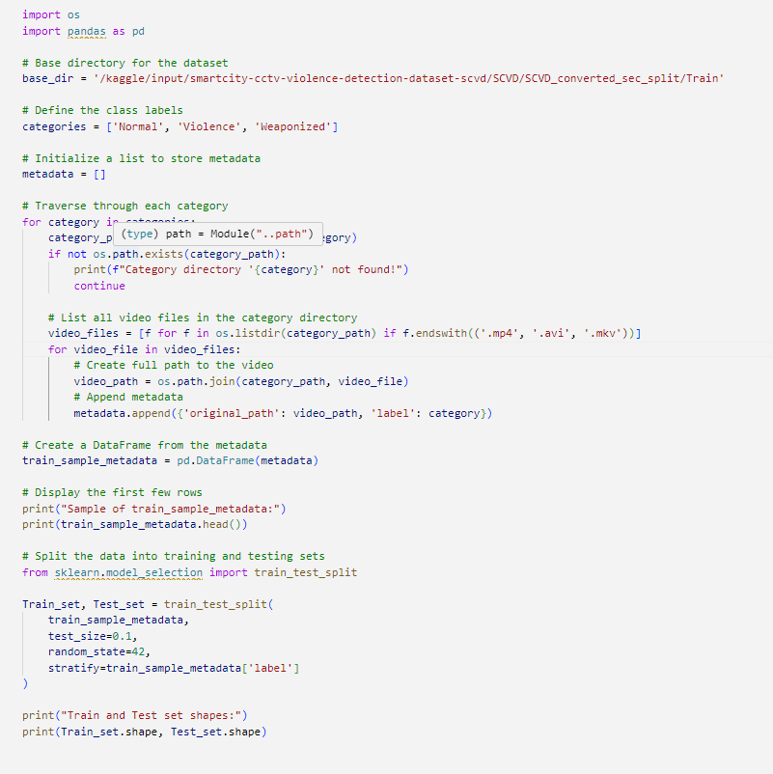

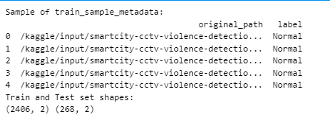

Department of CSE - SVECW | 35

**5.2.4: Model Training**

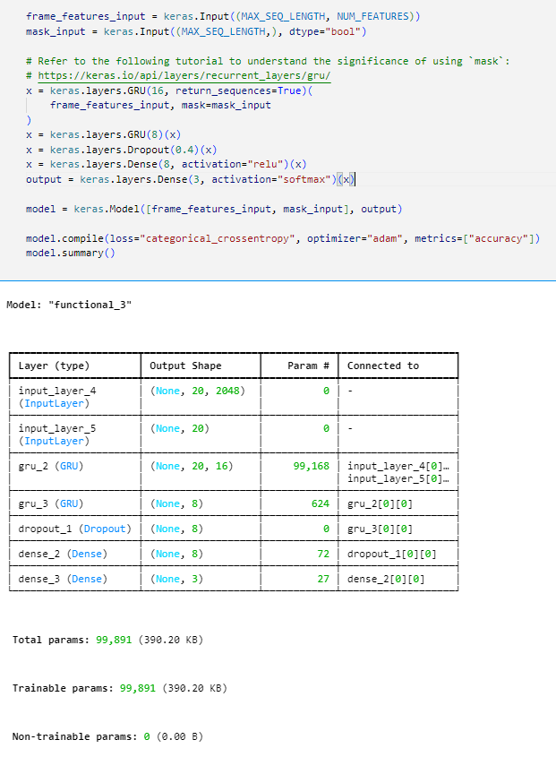 *Fig 5.2.4.1:Model Training using GRU*

Department of CSE - SVECW | 36

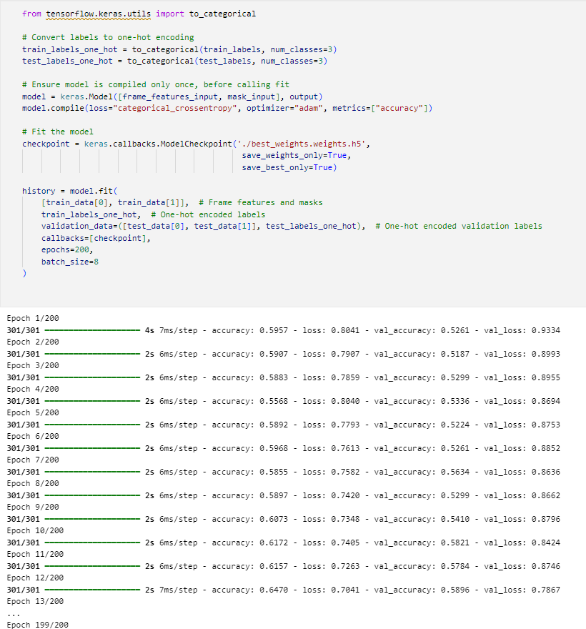

Department of CSE - SVECW | 37

Model Training using CNN:

**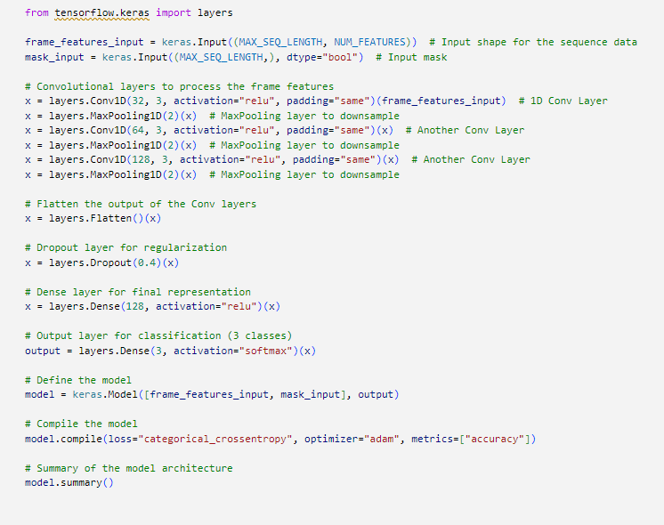  
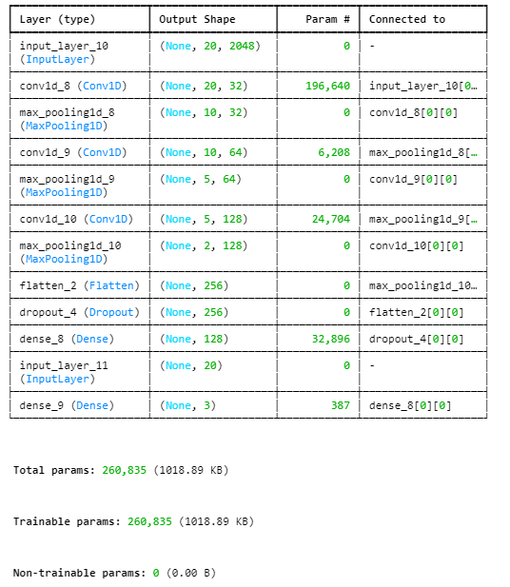**

Department of CSE - SVECW | 38

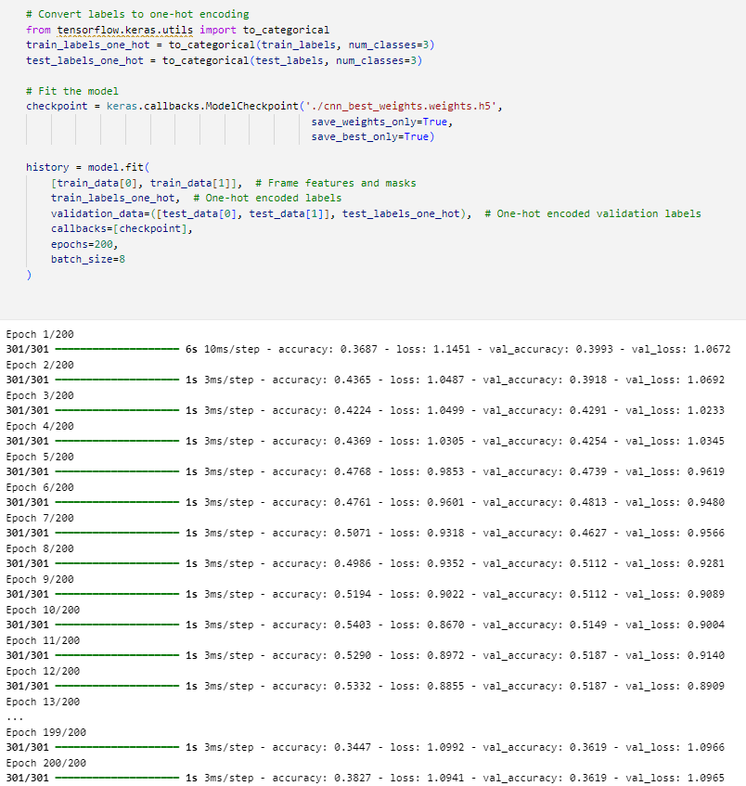

*Fig 5.2.4.2: Model Training using CNN*

Department of CSE - SVECW | 39

**5.2.5 : Data Visualization**

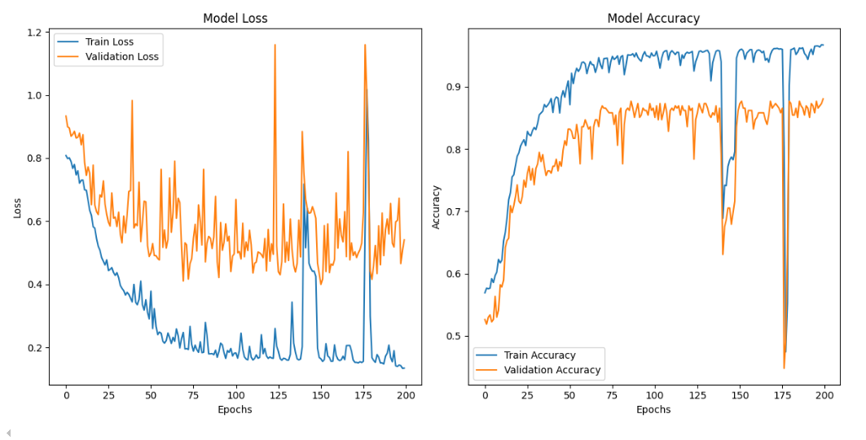

*Fig 5.2.5.1 : Model Loss and Accuracy of GRU**on both train and test data*

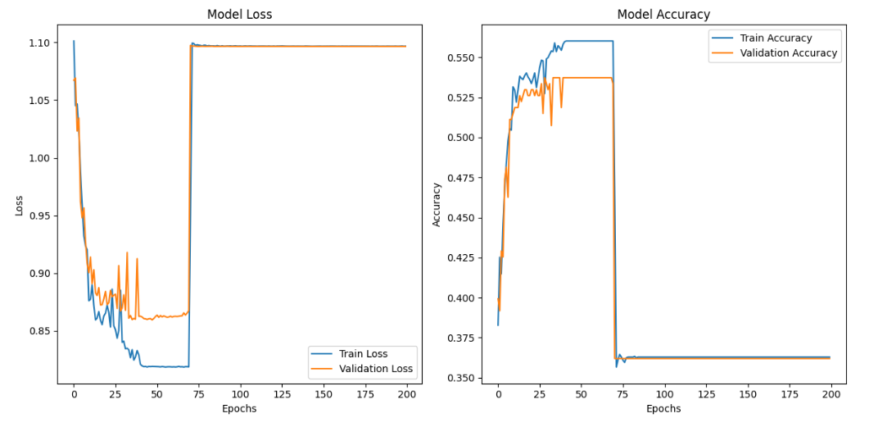

*Fig 5.2.5.2:Model Loss and Accuarcy of CNN on both train and test data*

Department of CSE - SVECW | 40

**5.3. Algorithms**

An algorithm is a step-by-step procedure or set of rules used to solve a problem or perform a task. It is a structured approach to processing input data and generating the desired output efficiently. Algorithms can be simple (e.g., sorting a list) or complex (e.g., deep learning for image recognition).

**How Algorithms Are Used in a Project:**

Algorithms are the foundation of software systems, providing structured solutions to complex problems. They enable various functionalities that enhance performance, efficiency, and automation. Here’s a deeper look at how algorithms contribute to software development:

1. **Data Processing** – Algorithms transform raw, unstructured data into meaningful, organized information. This includes:
   * **Sorting and Searching** – Efficient algorithms like Quicksort, Merge Sort, and Binary Search optimize data retrieval.
   * **Data Cleaning** – Removing inconsistencies, handling missing values, and standardizing data formats.
   * **Pattern Recognition** – Identifying trends and anomalies in datasets for applications in AI, machine learning, and analytics.
2. **Automation** – Algorithms reduce manual effort by executing repetitive and predefined tasks, enabling:
   * **Task Scheduling** – Algorithms like Round-Robin and Priority Scheduling optimize process execution in operating systems.
   * **Workflow Automation** – Rule-based algorithms power business process automation, chatbots, and robotic process automation (RPA).
   * **Self-Correcting Mechanisms** – Error-detection and correction algorithms improve reliability in software applications.
3. **Decision Making** – Intelligent algorithms analyse data and apply logic to support decision-making processes, such as:
   * **Artificial Intelligence and machine Learning**—Decision trees, neural networks, and reinforcement learning help with predictive analytics, recommendation systems, and automated reasoning.
   * **Rule-Based Systems** – Logical algorithms execute predefined conditions for fraud detection, medical diagnosis, and expert systems.
   * **Optimization of Business Strategies** – Algorithms help in dynamic pricing, supply chain management, and risk assessment.
4. **Optimization** – Algorithms enhance efficiency by reducing computational complexity and resource consumption, leading to:
   * **Time Complexity Reduction** – Advanced algorithms like Dynamic Programming and Divide-and-Conquer improve performance.
   * **Resource Allocation** – Load balancing algorithms distribute tasks efficiently in cloud computing and networking.
   * **Route Optimization** – Used in logistics, GPS navigation, and network packet routing to find the shortest or fastest paths.

Department of CSE - SVECW | 41

Overall, algorithms serve as the backbone of modern software, driving innovation and improving system performance in fields ranging from cybersecurity and cloud computing to artificial intelligence and data science.

**Algorithms for Real time Anomaly Detection in CCTV Footage using Deep Learning and with Alerting System**

**1. Password Hashing Algorithm**

Algorithm: SHA-256 Hashing  
Input: User password  
Output: Secure hashed password

Steps:

1. The user enters a password.
2. Apply SHA-256 hashing to generate a fixed-length secure hash.
3. Store the hashed password in the database.
4. During login, hash the input password and compare it with the stored hash.
5. If they match, authentication is successful.

**2. InceptionNet Algorithm**

Algorithm: Type of CNN Algorithm   
Input: video Frames  
Output: Feature Vector

Steps:

1. Data Preparation and Annotation.
2. Apply multiple convolution operations to extract spatial features.
3. Incorporates multiple convolutional filters of varying sizes within the same layer
4. Combines convolutions of various filter sizes (1x1, 3x3, 5x5) along with pooling layers.
5. Generate a 2048-dimensional feature vector for each frame.
6. Pass extracted features to the next stage (CNN) for Spatial, (GRU) for temporal analysis.

**3. ImageNet Model**

Model: Pretrained Feature Learning  
Input: Raw video frames from CCTV footage

Output: Pretrained weights for InceptionV3 feature extraction

Steps:

1. Load InceptionV3 model pretrained on ImageNet with weights="imagenet".
2. Remove the fully connected layers (include_top=False) to use it as a feature extractor.
3. Apply ImageNet preprocessing to normalize input frames.
4. Pass preprocessed video frames through InceptionV3 to extract deep spatial features.
5. Perform global average pooling to reduce feature dimensions to 2048.

Department of CSE - SVECW | 42

* ImageNet is a huge dataset of labeled images (14M+ images, 20K+ categories) used for training and evaluating computer vision models.
* It is famous for the ImageNet Large Scale Visual Recognition Challenge (ILSVRC), which led to breakthroughs in deep learning and CNN architectures like AlexNet, VGG, ResNet, and Inception.

**4. CNN Algorithm**

Algorithm: Convolutional Neural Network for Feature Extraction  
Input: Sequence of frame features extracted from video  
Output: Processed feature representation for classification

Steps:

1. Receive frame features as input
2. Apply a 1D Convolutional Layer to capture local spatial patterns.
3. Use MaxPooling to reduce dimensionality and retain important features.
4. Repeat Conv1D & MaxPooling with increased filters for deeper feature extraction.
5. Flatten the output to convert spatial features into a fully connected representation.
6. Apply Dropout (0.4) to prevent overfitting.
7. Pass through a Dense layer for feature compression.
8. Use a Softmax Output Layer to classify frames into Normal, Violence, or Weaponized.

The Convolutional Neural Network (CNN) is a type of deep learning algorithm that excels in processing structured grid-like data, particularly images and videos. It is particularly effective for tasks such as image classification, Object Detection and Video Analysis due to its ability to automatically learn spatial hierarchies of features from input data.

A CNN consists of multiple layers, including convolutional layers pooling layers, and fully connected layers, which enable it to extract complex patterns and structures in the data. CNNs are widely used in computer vision applications because of their ability to learn and generalize effectively from visual data.

Department of CSE - SVECW | 43

**CNN Confusion Matrix**

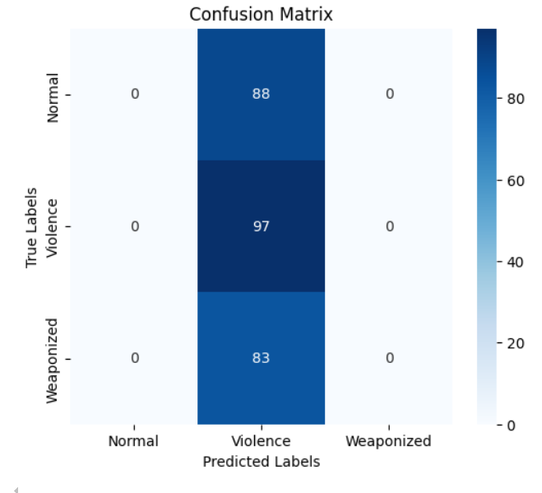

*Fig 5.3.1 : Confusion Matrix of the CNN-based model*

**Confusion Matrix Breakdown:**

|  |  |  |  |
| --- | --- | --- | --- |
| True \ Predicted | Normal | Violence | Weaponized |
| Normal | 0 | 88 | 0 |
| Violence | 0 | 97 | 0 |
| Weaponized | 0 | 83 | 0 |

**Analysis:**

* The CNN model classified every input as "Violence", regardless of the actual class.
* As a result:
  + All Normal and Weaponized samples were completely misclassified.
  + Only the Violence class was detected correctly.
* This indicates severe model bias and poor generalization.
* Such a result may arise due to:
  + Imbalanced training data
  + Improper feature extraction
  + Overfitting to the dominant class during training

Department of CSE - SVECW | 44

**Key Observations:**

* The model has **zero class discrimination** and completely **fails at multi-class classification**.
* It might have learned to always predict the majority class if the training data was imbalanced.
* This matrix shows **high recall** for the Violence class but **zero precision** for the other two.

**CNN Classification Report**

|  |  |  |  |  |
| --- | --- | --- | --- | --- |
| Class | Precision | Recall | F1-Score | Support |
| Normal | 0.00 | 0.00 | 0.00 | 88 |
| Violence | 0.36 | 1.00 | 0.53 | 97 |
| Weaponized | 0.00 | 0.00 | 0.00 | 83 |
| Accuracy |  |  | 0.36 | 268 |
| Macro Avg | 0.12 | 0.33 | 0.18 | 268 |
| Weighted Avg | 0.13 | 0.36 | 0.19 | 268 |

**Interpretation:**

* The model only predicted the Violence class, ignoring the other two completely.
* Precision and recall are zero for Normal and Weaponized, indicating complete failure in identifying these classes.
* The accuracy dropped to 36%, which is equal to the proportion of actual Violence samples (97/268).
* Very poor macro and weighted averages suggest severe class imbalance or model bias.

**Conclusion:**This model is highly unreliable for real-world applications. It suffers from class imbalance, overfitting to a single class, or poor training. It is not suitable for deployment without significant improvement.

**5. GRU Algorithm**

Algorithm: Gated Recurrent Unit (GRU) for Temporal Sequence Learning  
Input: Sequence of frame features extracted from video  
Output: Processed feature representation for classification

Department of CSE - SVECW | 45

Steps:

1. Receive frame features as input.
2. Use a masking layer to ignore padding values in sequences.
3. Apply the first GRU layerto process sequential dependencies in video frames.
4. Apply the second GRU layer to reduce dimensionality while maintaining temporal context.
5. Apply Dropout to prevent overfitting.
6. Pass through a Dense layer for feature compression.
7. Use a Softmax Output Layer to classify video sequences into Normal, Violence, or Weaponized.

**GRU Confusion Matrix**

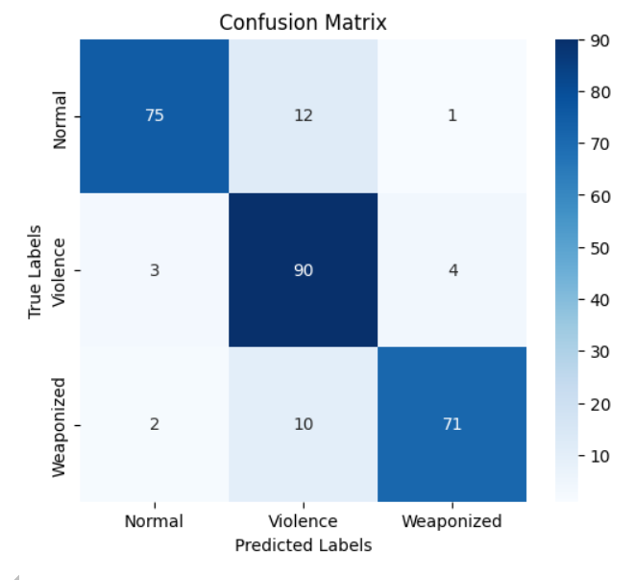

*Fig 5.3.2: Confusion Matrix of the GRU-based model*

**Confusion Matrix Breakdown:**

|  |  |  |  |
| --- | --- | --- | --- |
| True/Predicted | Normal | Violence | Weaponized |
| Normal | 75 | 12 | 1 |
| Violence | 3 | 90 | 4 |
| Weaponized | 2 | 10 | 71 |

**Analysis:**

* The model has a good balance in predicting all three classes.
* It correctly classified:
  + 75 out of 88 "Normal" samples
  + 90 out of 97 "Violence" samples
  + 71 out of 83 "Weaponized" samples

Department of CSE - SVECW | 46

* Some misclassifications occurred:
  + 12 Normal instances were classified as Violence
  + 10 Weaponized instances were classified as Violence
* Overall, the GRU model shows strong capability in handling sequential data and performed well across all categories.

**Key Observations:**

* This model demonstrates a good balance in predicting all three categories.
* Misclassifications are relatively low.
* It indicates a model that is capable of distinguishing between different behaviors or threat levels in the footage.

**GRU Classification Report**

|  |  |  |  |  |
| --- | --- | --- | --- | --- |
| Class | Precision | Recall | F1-Score | Support |
| Normal | 0.94 | 0.85 | 0.89 | 88 |
| Violence | 0.80 | 0.93 | 0.86 | 97 |
| Weaponized | 0.93 | 0.86 | 0.89 | 83 |
| Accuracy |  |  | 0.88 | 268 |
| Macro Avg | 0.89 | 0.88 | 0.88 | 268 |
| Weighed Avg | 0.89 | 0.88 | 0.88 | 268 |

**Interpretation:**

* The model shows high precision and recall across all classes.
* Violence class has slightly lower precision, but a high recall (0.93), indicating the model captures most violent cases, though some may be false positives.
* Overall accuracy: 88%, which is strong for a multi-class classification task.
* Macro and weighted averages are both 0.88, showing balanced performance across classes.

**Conclusion:**This model is effective and reliable for classifying surveillance data into Normal, Violence, and Weaponized categories. It can be confidently deployed in real-time threat detection systems.

Department of CSE - SVECW | 47

**6. SMTP Protocol (Simple Mail Transfer Protocol)**

Algorithm: Email Notification for Anomaly Alerts  
Input: Anomaly detection result and snapshot of the anomaly frame  
Output: Email alert sent to the admin with the attached anomaly frame

Steps:

1. Establish a connection with the SMTP server.
2. Authenticate using sender email credentials.
3. Create an email message with subject, recipient, and body content.
4. Attach the anomaly snapshot to the email for verification.
5. Send the email to the specified recipient (admin/security team).
6. Close the SMTP connection after successfully sending the alert.

**5.4. Screens**

Screens refer to the graphical user interface (GUI) or application screens that showcase the system's functionality. These screens help visually represent how users interact with the system and provide a clear understanding of its design, workflow, and usability.

**Purpose of Screens in a Report**

1. Visual Representation: This helps stakeholders understand how the system works.
2. User Interaction Flow: Demonstrates the step-by-step process of how users navigate through the application.
3. Functionality Showcase: Displays different modules and features of the system.
4. Testing & Validation: Screens help verify that the system meets the expected requirements.

**1. Registration Page and Login Page:**

* Secure user authentication with sign-up and login functionality.
* Displays success/error messages based on authentication status

Department of CSE - SVECW | 48

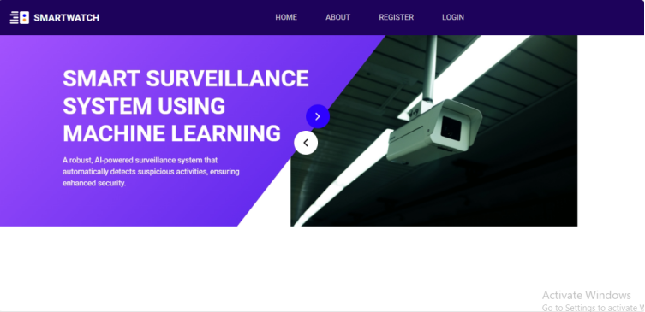

*Fig 5.4.1: index page*

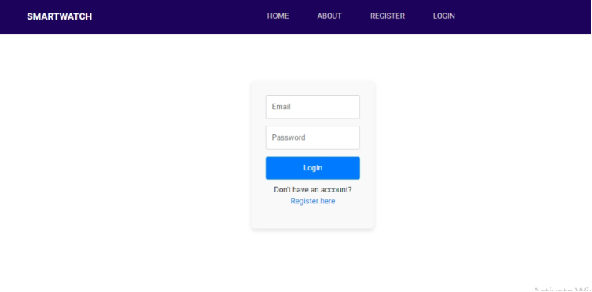  *Fig 5.4.2: Login page*

Department of CSE - SVECW | 49

**2. Home Screen**

* Provides a dashboard with options for file uploads, AI interactions, and extracted text display.



*Figure 5.4.3: User Home Page*

**3. File Upload Screens**

* Allows users to upload video files of three formats MP4, MKV, AVI.
* Displays classification for further processing.

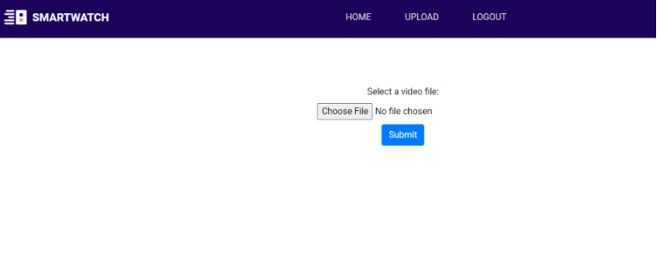

*Fig 5.4.4: Upload Page*

Department of CSE - SVECW | 50

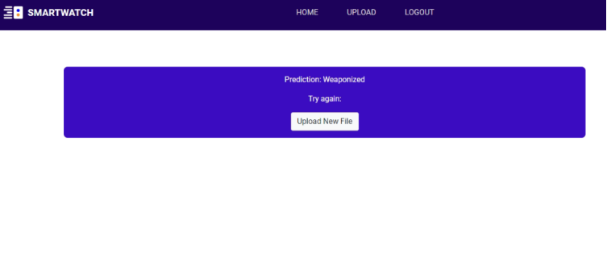

***Fig 5.4.5: Result of Anomaly detected***

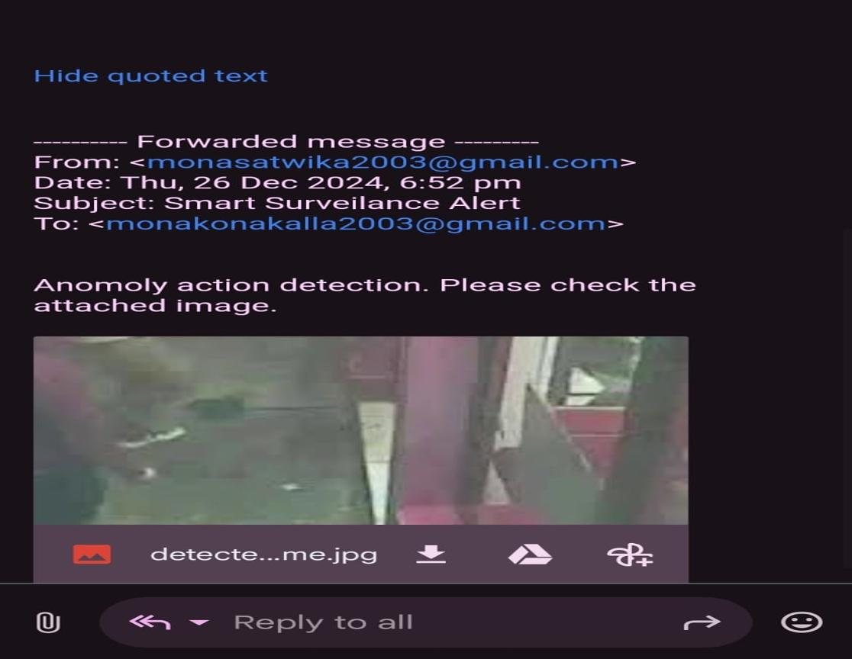  
  
 *Fig 5.4.5: Sending alert through mail to Admin*

Department of CSE - SVECW | 51

**6. System Testing**

Department of CSE - SVECW | 52

**6.1 Introduction**

Software testing is a critical phase in the software development life cycle (SDLC) that ensures the quality, reliability, and performance of a software application by identifying and resolving defects before deployment. It is a systematic process of evaluating a software product to verify that it meets specified requirements and functions as intended. The primary objective of software testing is to detect errors, gaps, or missing requirements, thereby enhancing the overall user experience and ensuring that the software is free of faults.

In the context of our project, “Anomaly Detection in CCTV Footage Using Deep Learning with an Alerting System,” software testing plays a vital role in validating the accuracy of anomaly detection, the efficiency of the alerting mechanism, and the seamless integration of various components. Given the critical nature of real-time surveillance systems, comprehensive testing is essential to ensure that anomalies are detected promptly and that alerts are triggered accurately without false positives or negatives.

Software testing can be broadly categorized into two types: manual testing and automated testing. Manual testing involves human intervention to execute test cases and observe the outcomes, while automated testing uses scripts and testing tools to perform tests efficiently and repeatedly. Additionally, testing approaches are often classified into black box testing and white box testing. Black box testing focuses on the software's functionality without considering its internal code structure, whereas white box testing examines the internal logic, code paths, and data flow.

Another essential aspect of software testing is the testing levels, which include unit testing, integration testing, system testing, and acceptance testing. Unit testing focuses on individual components to ensure they function correctly in isolation. Integration testing checks the interaction between integrated components to identify interface-related issues. System testing validates the complete and integrated software to ensure it meets the requirements. Finally, acceptance testing is performed to verify that the software is ready for delivery by ensuring it meets business and user requirements.

For our project, we have adopted a comprehensive testing strategy that includes unit testing for individual functions such as anomaly detection and alert triggering, integration testing to validate the interaction between the detection model and the alert system, and functional testing to ensure that the system performs as expected under various scenarios. Additionally, both white box and black box testing techniques have been employed to assess internal code logic and overall system behavior.

In conclusion, software testing is indispensable in delivering a reliable, secure, and high-quality surveillance system. By implementing a robust testing strategy, we aim to ensure that our anomaly detection and alerting system performs accurately and efficiently, providing timely notifications of potential threats and enhancing security monitoring capabilities.

Department of CSE - SVECW | 53

**6.2 Testing Methods**

**1. Unit Testing**

Unit testing focuses verification effort on the smallest unit of Software design which is the module. Unit testing exercises specific paths in a module’s control structure to ensure complete coverage and maximum error detection. This test focuses on each module individually, ensuring that it functions properly as a unit. Hence, the naming is Unit Testing. During this testing, each module is tested individually and the module interfaces are verified for consistency with design specifications. All important processing paths are tested for the expected results. Unit Testing is a type of software testing where individual units or components of software are tested. The purpose is to validate that each unit of the software code performs as expected. Unit Testing is done during the development (coding phase) of an application by the developers. Unit Tests isolate a section of code and verify its correctness. A unit may be an individual function, method, procedure, module, or object. In SDLC, STLC, and V Models, Unit testing is the first level of testing done before integration testing. Unit testing is a White Box testing technique that is usually performed by the developer. However, in a practical world due to time crunch or reluctance of developers to test, QA engineers also do unit testing.

* + Unit tests help to fix bugs early in the development cycle and save costs.
  + It helps the developers to understand the testing code base and enables them to make changes quickly.
  + Good unit tests serve as project documentation
  + Unit tests help with code reuse.

Migrate both your code and your tests to your new project. weak the code until the tests run again. To execute Unit Tests, developers write a section of code to test a specific function in the software application. Developers can also isolate this function to test more rigorously which reveals unnecessary dependencies between the function being tested and other units so the dependencies can be eliminated. Developers generally use the Unit Test framework to develop automated test cases for unit testing.

Unit Testing is of two types:

* + Manual
  + Automatic

Unit testing is commonly automated but may still be performed manually. Software Engineering does not favor one over the other but automation is preferred.

**Key Aspects of Unit Testing:**

* Tests specific modules or functions.
* Performed after coding is completed for an individual unit.
* Helps identify defects early in the development cycle.
* Uses test cases with known inputs and expected outputs.

Department of CSE - SVECW | 54

**2. Integration Testing**

Integration testing addresses the issues associated with the dual problems of verification and program construction. After the software has been integrated a set of high-order tests are conducted. The main objective of this testing process is to take modules and build a program structure that has been dictated by design. Integration Testing is defined as a type of testing where software modules are integrated logically and tested as a group. A typical software project consists of multiple software modules, coded by different programmers. The purpose of this level of testing is to expose defects in the interaction between these software modules when they are integrated. Integration Testing focuses on checking data communication among these modules. Hence it is also termed as ‘I&T’ (Integration and Testing), ‘String Testing’, and sometimes ‘Thread Testing’.

* A Module, in general, is designed by an individual software developer whose understanding and programming logic may differ from other programmers. Integration Testing becomes necessary to verify the software modules work in unity.
* At the time of module development, there are wide chances of change in requirements by the clients. These new requirements may not be unit tested and hence system integration Testing becomes necessary.
* Interfaces of the software modules with the database could be erroneous.
* External Hardware interfaces, if any, could be erroneous.
* Inadequate exception handling could cause issues.

Integration test case differs from other test cases in the sense it focuses mainly on the interfaces & flow of data/information between the modules. Here priority is to be given for the integrating links rather than the unit functions which are already tested.

**Integration test approaches –**

There are four types of integration testing approaches. Those approaches are the following:

* + Big-Bang Integration Testing
  + Bottom-Up Integration Testing
  + Top-Down Integration Testing
  + Mixed Integration Testing

**Big-Bang Integration Testing:**

It is the simplest integration testing approach, where all the modules are combined, and the functionality after the completion of individual module testing. In simple words, all the modules of the system are simply put together and tested. This approach is practicable only for very small systems. If an error is found during the integration testing, it is very difficult to localize the error as the error may potentially belong to any of the modules being integrated. So, debugging errors reported during Big Bang integration testing is very expensive to fix. The Big Bang integration workflow diagram is a process diagram that shows how different parts of a system are integrated. It is typically used to show how different software components are integrated. It is a graphical representation of the software development process that is used in many organizations. It is a process that starts with the idea for a new software project and ends with the delivery of the software to the customer.

Department of CSE - SVECW | 55

Big-Bang Integration Testing is a type of integration testing where all the individual modules of a software system are combined at once and tested as a complete system. This approach is straightforward but can be complex to manage, especially in large-scale applications.

**Characteristics of Big-Bang Integration Testing:**

1. **Single-Step Integration:** Unlike incremental integration testing, where modules are combined step by step, Big-Bang integration testing involves integrating all modules simultaneously after individual unit testing is completed.
2. **No Immediate Dependencies Handling:** Since all modules are integrated at once, there is no need to handle dependencies between individual modules during the integration phase.
3. **Late Testing Stage:** The actual integration testing is postponed until all modules are developed and tested individually.
4. **High-Risk Approach:** As errors from multiple modules can interfere with each other, identifying the root cause of a defect becomes difficult.

**Advantages of Big-Bang Integration Testing:**

* **Simplicity in Planning:** Since all components are integrated in one go, there is no need for a complex integration strategy.
* **No Need for Stubs and Drivers:** Unlike incremental integration testing, where dummy components (stubs and drivers) are required, Big-Bang testing does not require them because all modules are available at the time of testing.
* **Saves Time for Small Projects:** For small-scale applications with fewer modules, this approach can be quicker than incremental testing.

**Disadvantages of Big-Bang Integration Testing:**

* **Difficult Error Localization:** If an error is detected, it becomes challenging to determine which module is responsible, as multiple components are being tested together.
* **Late Bug Detection:** Since integration testing happens only after all modules are ready, defects that arise from module interactions are found late in the development process.
* **Higher Cost of Debugging:** Fixing errors in an integrated system is more time-consuming and expensive because multiple modules may need to be modified.
* **Lack of Early Feedback:** Developers do not receive feedback about integration issues until the entire system is assembled, which can delay the project timeline.

Department of CSE - SVECW | 56

**When to Use Big-Bang Integration Testing:**

* **For Small Systems:** This approach works well when dealing with a small number of modules, as debugging is manageable.
* **When Modules Are Readily Available:** If all components are developed and tested independently without delays, Big-Bang testing can be implemented efficiently.
* **When Time Constraints Are Minimal:** Since debugging takes longer, this method is not ideal for projects with strict deadlines.

**Big-Bang Integration Workflow:**

The Big Bang integration workflow is a visual representation of how various software modules are combined and tested. It typically consists of:

* Individual modules being developed separately.
* A single step where all modules are integrated.
* Testing of the entire system in one go.
* Debugging and fixing defects.
* Delivery of the final software product.

Big-Bang Integration Testing is an approach that is best suited for smaller projects with limited modules, as it simplifies the testing process. However, for larger systems, it poses significant challenges, such as difficulty in debugging and late defect detection. Organizations often prefer incremental integration testing, such as Top-Down, Bottom-Up, or Hybrid integration, to minimize risks and improve testing efficiency.

**Bottom-Up Integration Testing:**

Bottom-up Testing is a type of incremental integration testing approach in which testing is done by integrating or joining two or more modules by moving upward from bottom to top through the control flow of the architecture structure. In these, low-level modules are tested first, and then high-level modules are tested. This type of testing or approach is also known as inductive reasoning and is used as a synthesis synonym in many cases. Bottom-up testing is user-friendly testing and results in an increase in overall software development. This testing results in high success rates with long-lasting results.

**Processing:**

Following are the steps that are needed to be followed during the processing:

* 1. Clusters are formed by merging or combining low-level modules or elements. These clusters are also known as builds that are responsible for performing certain secondary or subsidiary functions of software.
  2. It is important to write a control program for testing. These control programs are also known as drivers or high-level modules. It simply coordinates the input and output of a test case.
  3. Testing is done on the entire build or cluster containing low-level modules.
  4. Lastly, control programs or drivers or high-level modules are removed and clusters are integrated by moving upward from bottom to top in the program structure with the help of control flow.

Department of CSE - SVECW | 57

**Top-Down Integration Testing**:

Top-down testing is a type of incremental integration testing approach in which testing is done by integrating or joining two or more modules by moving down from top to bottom through the control flow of the architecture structure. In these, high-level modules are tested first, and then low-level modules are tested. Then, finally, integration is done to ensure that the system is working properly. Stubs and drivers are used to carry out this project. This technique is used to increase or stimulate the behavior of Modules that are not integrated into a lower level.

**Processing:**

Following are the steps that are needed to be followed during processing:

1. Test driver represents the main control module also known as a high-level module and stubs are generally used for all low-level modules that directly subordinate (present or rank below another) to high-level modules.
2. In this, testing takes place from the bottom. So, high-level modules are tested first in isolation.
3. After this, low-level modules subordinated modules, or stubs replace high-level modules one by one at a time. This can be done using methods like depth-first or breadth search.
4. The process is repeated until each module is integrated and tested.
5. Another stub replaces the present real or control module after completion of each set of tests. These stubs act as a temporary replacement for a called module (stubs) and give the same result or output as the actual product gives.
6. To check if any defect or any error is occurring or present, regression testing is done and it’s important to reduce any side effects that might be caused due to errors occurring.

**Understanding the Top-Down and Bottom-Up Approaches**

* In a top-down approach, testing begins at the highest-level module, progressing downward by integrating and testing lower-level modules sequentially. However, this method requires that the top-level module be fully coded and unit-tested before testing can begin. If lower-level modules are not yet developed, stubs (temporary placeholder modules) are used to simulate their functionality.
* In a bottom-up approach, testing starts with the lower-level modules and progresses upwards by integrating and testing higher-level modules. This approach ensures that foundational components are validated early, but testing cannot proceed until all lower-level modules are developed. In cases where higher-level modules are not yet ready, drivers (temporary test harnesses) are used to simulate their behavior.

Department of CSE - SVECW | 58

**Mixed Integration Testing**

A mixed integration testing is also called sandwiched integration testing. A mixed integration testing follows a combination of top down and bottom-up testing approaches. In a top-down approach, testing can start only after the top-level module has been coded and unit tested. In the bottom-up approach, testing can start only after the bottom level modules are ready. This sandwich or mixed approach overcomes this shortcoming of the top-down and bottom-up approaches. It is also called the hybrid integration testing. also, stubs and drivers are used in mixed integration testing.

**Key Aspects of Integration Testing:**

* Verifies that modules interact properly.
* Identifies interface defects between components.
* Detects inconsistencies in data flow across modules.
* Ensures smooth interaction between subsystems.

**3. Functional Testing**

Functional testing is a type of software testing that evaluates the functionality of a software application to ensure it meets the specified requirements. Unlike white-box testing, functional testing focuses on what the system does rather than how it does it. It is a black-box testing technique, meaning that the tester does not need to have knowledge of the internal structure or code implementation of the software.

Functional testing involves checking user interfaces, APIs, databases, security features, and other functional components of a system to validate that the application behaves as expected under various conditions.

**Objectives of Functional Testing:**

Functional testing ensures that:

* All required functionalities of the software have been properly implemented and work correctly.
* The software meets its specified requirements and business objectives.
* Input data is correctly processed, and the expected output is produced.
* Edge cases and boundary conditions are handled properly.
* The integration between different system components functions seamlessly.

**Why Perform Functional Testing?**

Functional testing is performed for the following reasons:

* To validate that the system functions as per the specified requirements.
* To ensure a smooth and error-free user experience.
* To detect any defects or issues in the application’s features.
* To verify that all system components interact correctly.
* To ensure that critical business processes are working as intended.
* To check for compliance with regulatory and industry standards.

Department of CSE - SVECW | 59

**Types of Bugs Identified in Functional Testing:**

Functional testing helps uncover the following types of defects:

* **Incorrect or missing functionality** – If any required feature is absent or does not work as expected.
* **UI and usability defects** – Issues with navigation, responsiveness, or accessibility.
* **Error handling and validation issues** – Ensuring proper error messages, input validation, and exception handling.
* **Integration issues** – Problems with communication between different components or systems.
* **Performance-related defects** – Slowness or crashes under certain conditions.

**Steps to Perform Functional Testing:**

Step 1 – Identify Test Requirements:

* Gather functional requirements from business documents, use cases, or specifications.
* Understand the expected behavior of the system.

Step 2 – Create Test Cases and Scenarios:

* Develop test cases that cover all functionalities.
* Include positive and negative test scenarios to check different input conditions.

Step 3 – Execute Test Cases:

* Run the functional tests manually or using automation tools.
* Validate the expected output against the actual output.

Step 4 – Report and Fix Defects:

* Log any identified defects and assign them for resolution.
* Retest the application after bug fixes.

Step 5 – Perform Regression Testing:

* Re-run functional tests to ensure that new changes have not broken existing functionality.

**Functional Testing Techniques:**

Several techniques are used in functional testing to ensure software quality:

1. Equivalence Partitioning:
   * Inputs are divided into valid and invalid partitions to reduce the number of test cases while maintaining coverage.
2. Boundary Value Analysis:
   * Focuses on testing the boundaries of input ranges, as defects often occur at boundary conditions.
3. Decision Table Testing:
   * Uses decision tables to test various combinations of inputs and corresponding outputs.
4. State Transition Testing:
   * Validates that the system behaves correctly as it transitions between different states based on user actions.
5. Use Case Testing:
   * Ensures that the system behaves as expected in real-world user scenarios.

Department of CSE - SVECW | 60

1. Smoke Testing:
   * A quick test to verify that the most critical functionalities of the application are working.
2. Sanity Testing:
   * A focused test to check specific functionalities after bug fixes.

**Key Aspects of Functional Testing:**

* Tests application features against the requirements.
* Focuses on input validation, process execution, and output accuracy.
* Ensures compliance with business logic and user expectations.

**4. White Box Testing**

White box testing (also known as clear, glass box, or structural testing) is a testing technique that evaluates the code and the internal structure of a program.

White box testing involves looking at the structure of the code. When you know the internal structure of a product, tests can be conducted to ensure that the internal operations are performed according to the specifications. And all internal components have been adequately exercised.

We perform white box testing for the following reasons:

* + That all independent paths within a module have been exercised at least once.
  + All logical decisions verified on their true and false values.
  + All loops executed at their boundaries and within their operational bounds internal data structures validity.
* To discover the following types of bugs:
  + Logical errors tend to creep into our work when we design and implement functions, conditions, or controls that are out of the program
  + The design errors are due to the difference between the logical flow of the program and the actual implementation.
  + Typographical errors and syntax checking.

**Steps to Perform White Box Testing:**

Step 1 – Understand the functionality of an application through its source code. Which means that a tester must be well versed with the programming language and the other tools as well techniques used to develop the software.

Step 2– Create the tests and execute them.

In this testing method, the design and structure of the code are known to the tester.

Programmers of the code conduct this test on the code.

Department of CSE - SVECW | 61

**Below are some White-box testing techniques:**

• Control-flow testing – The purpose of control-flow testing is to set up test cases that cover all statements and branch conditions. The branch conditions are tested for both being true and false so that all statements can be covered.

• Data-flow testing – This testing technique emphasis to cover all the data variables included in the program. It tests where the variables were declared and defined and where they were used or changed.

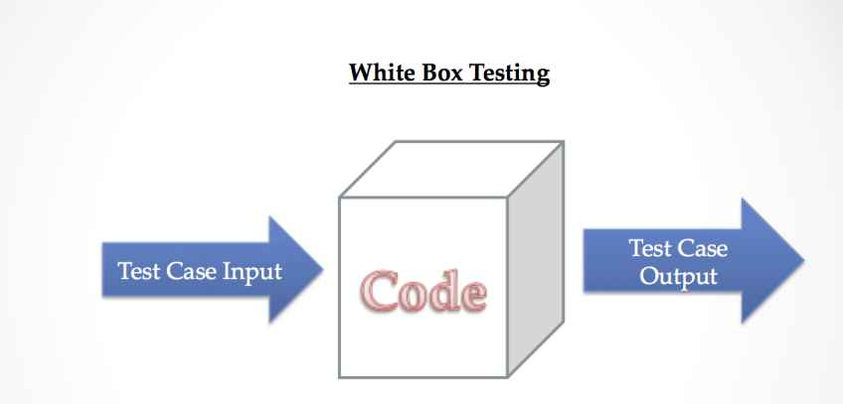

**Key Aspects of White Box Testing:**

* Examines code logic, loops, and conditions.
* Helps identify hidden vulnerabilities and logical errors.
* Requires programming knowledge.
* Ensures code efficiency and security.

**5. Black Box Testing**

Black Box Testing is also known as behavioral, opaque-box, closed-box, specification, or eye-to-eye testing.

It is a Software Testing method that analyzes the functionality of a software/application without knowing much about the internal structure/design of the item that is being tested and compares the input value with the output value. The main focus in Black Box Testing is on the functionality of the system as a whole.

The term Behavioral Testing is also used for Black Box Testing.

Behavioral test design is slightly different from the black-box test design because the use of internal knowledge isn't strictly forbidden, but it's still discouraged. Each testing method has its advantages and disadvantages. Some bugs cannot be found using the only black box or only white box technique. The majority of the applications are tested by the Black Box method. We need to cover the majority of test cases so that most of the bugs will get discovered by a BlackBox method. In this testing method, the design and structure of the code are not known to the tester, and testing engineers and end users conduct this test on the software.

Department of CSE - SVECW | 62

**Black-box testing techniques:**

* Equivalence class - The input is divided into similar classes. If one element of a class passes the test, it is assumed that all the class is passed.
* Boundary values - The input is divided into higher and lower-end values. If these values pass the test, it is assumed that all values in between may pass too.
* Cause-effect graphing - In both previous methods, only one input value at a time is tested. Cause (input) – Effect (output) is a testing technique where combinations of input values are tested systematically.
* Pair-wise Testing - The behavior of software depends on multiple parameters. In pairwise testing, the multiple parameters are tested pair-wise for their different values.
* State-based testing - The system changes state on the provision of input. These systems are tested based on their states and input.

**Generic steps of black box testing**:

* The black box test is based on the specification of requirements, so it is examined in the beginning.
* In the second step, the tester creates a positive test scenario and an adverse test scenario by selecting valid and invalid input values to check that the software is processing them correctly or incorrectly.
* In the third step, the tester develops various test cases such as a decision table, all pairs test, equivalent division, error estimation, cause-effect graph, etc.
* The fourth phase includes the execution of all test cases.
* In the fifth step, the tester compares the expected output against the actual output.
* In the sixth and final step, if there is any flaw in the software, then it is cured and tested again.

Department of CSE - SVECW | 63

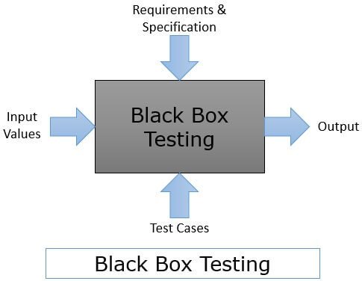

**Key Aspects of Black Box Testing:**

* Tests system behavior from a user’s perspective.
* Ensures correct input processing and output generation.
* Does not require knowledge of source code.
* Identifies usability and performance issues.

**6.3 Test Cases**

A test case is a set of conditions or actions used to verify whether a software application works as expected. Below are test cases for different testing approaches:

**Unit Testing Test Cases:**

**Purpose:** To test individual components or functions of the system.

**Focus:** Testing the smallest parts of the system like model accuracy, alert function, etc.

**Test Case 1:** **Anomaly Detection Capability**

* **Test Case Description:** Test if the model’s prediction method correctly identifies anomalies in CCTV footage.
* **Preconditions:**

1. The model is trained and deployed.
2. Required libraries and dependencies are installed.

* **Test Data:** Sample frames containing both normal and anomalous events.
* **Test Steps:**

1. Pass a normal frame to the model’s prediction function (model.predict())

Department of CSE - SVECW | 64

1. Record the model's output labels (e.g., “Normal” or “Anomaly”).

* **Expected Result:**

1. Normal frame: The model outputs “Normal”
2. Anomalous frame: The model outputs “Anomaly” (Violence or Weaponized)

* **Status:** Passed



**Integration Testing Test Cases:**

**Purpose:** To test the interactions between different modules of the system.  
**Focus:** Integration of detection model, alert system, and database.

**Test Case 1: Detection and Alert System Integration**

* **Test Case Description:** Test if detection module passes anomaly data to alert system.
* **Preconditions:** Both modules deployed.

Department of CSE - SVECW | 65

**Test Steps:**

* 1. Simulate an anomaly.
  2. Check if alert is triggered.
* **Expected Result:** Alert system receives correct data and triggers alert.
* **Status:** Passed

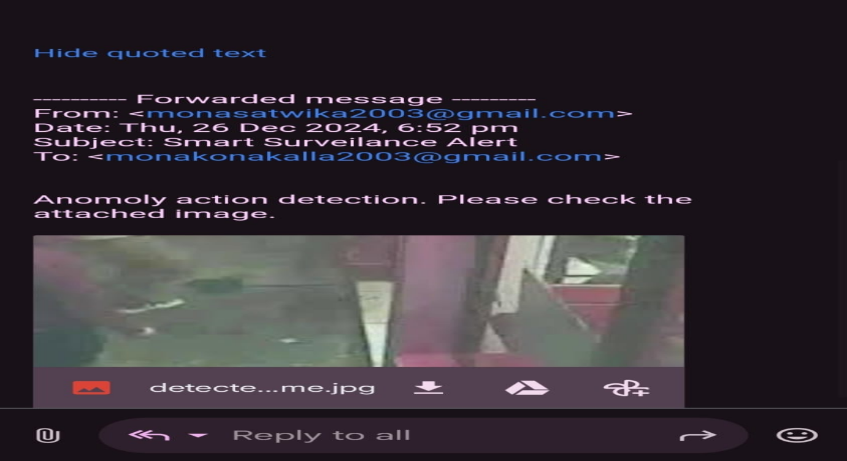

**Functional Testing Test Cases:**

**Purpose:** To verify that the system functions according to requirements.  
**Focus:** End-to-end testing of features like alert generation, logging, etc.

**Test Case : Real-Time Alert Generation**

* **Test Case ID:** FT-01
* **Description:** Test real-time alert for anomalies.
* **Test Steps:**
  1. Input footage with an anomaly.
  2. Check alert generation time.
* **Expected Result:** Alert within 5 seconds of detection.
* **Status:** Passed

Department of CSE - SVECW | 66

**White Box Testing Test Cases:**

**Purpose:** To test internal structures and code logic.  
**Focus:** Code paths, conditions, loops in detection algorithm.

**Test Case : Condition Testing in Alert System**

* **Test Case Description:** Test conditional statements in the alert-triggering code.
* **Preconditions:**
  + Alert system integrated and source code access available.
* **Test Steps:**
  1. Simulate different conditions:
     1. Condition 1: Anomaly detected → Trigger alert.
     2. Condition 2: No anomaly detected → No alert.
  2. Observe if correct conditions are triggered.
* **Expected Result:**
  + Correct alerts based on conditions.
* **Status:** Passed

**Black Box Testing Test Cases:**

**Purpose:** To test system functionality without knowing internal code.  
**Focus:** Input-output behavior of the system.

**Test Case 4: Handling Invalid Inputs**

* **Test Case Description:** Test how the system handles invalid video inputs.
* **Test Data:**
  + Unsupported file formats
* **Test Steps:**
  + - Upload a unsupported file.
    - Check system response.

Department of CSE - SVECW | 67

* **Expected Result:**
  + Display error message: **“Invalid file format”**
* **Status:** Passed

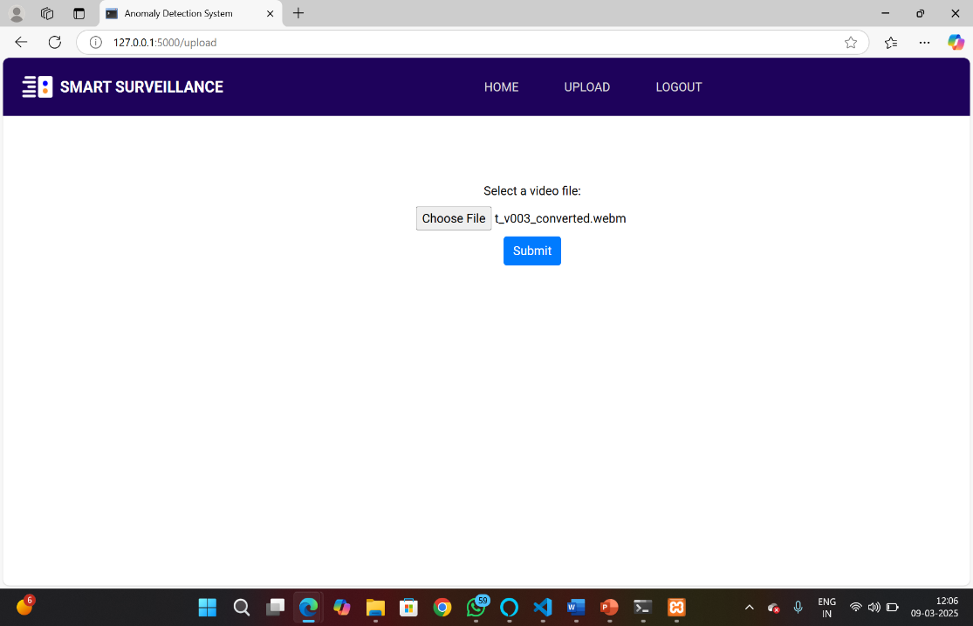

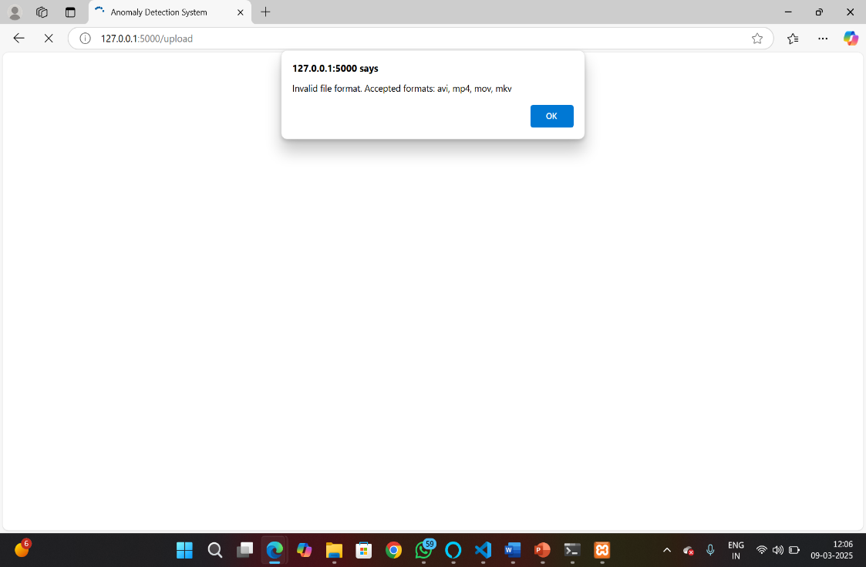

Department of CSE - SVECW | 68

**7. Conclusion**

Department of CSE - SVECW | 69

In conclusion, The development of an advanced surveillance system leveraging deep learning techniques, particularly the hybrid combination of Convolutional Neural Networks (CNNs) for spatial feature extraction and Gated Recurrent Units (GRUs) for temporal sequence modeling, has shown promising results in video activity classification. By categorizing videos into Normal, Violence, and Weaponized activities, the system provides a powerful tool for real-time monitoring and threat detection, significantly enhancing public safety and security measures.

Through the use of CNNs, the system effectively captures spatial features from video frames, enabling it to identify objects and actions within scenes. The integration of GRUs allows the system to understand the temporal dynamics of video sequences, ensuring that patterns and trends over time are accurately detected. This hybrid approach offers an optimized solution to the complexities of video analysis, where both individual frame content and temporal relationships are essential for correct classification.

The system’s robust performance, trained on a diverse video dataset, ensures it can handle a wide variety of real-world scenarios, demonstrating high accuracy and adaptability. The incorporation of optimization techniques further enhances the system's efficiency, making it suitable for deployment in real-world surveillance applications where real-time processing is crucial.

In conclusion, this project highlights the potential of deep learning in transforming surveillance systems by providing high-accuracy, real-time activity detection and classification. The proposed solution not only improves security measures but also contributes to the ongoing evolution of smart surveillance technologies, offering significant advancements in threat detection and public safety management. As the system evolves, further refinements in model accuracy, computational efficiency, and real-time deployment could lead to even more robust security solutions for modern environments

Department of CSE - SVECW | 70

**8. Bibliography**

Department of CSE - SVECW | 71

1. H Y. Zhang, X. Liu, and L. Zhang, "Real-time activity recognition in surveillance videos using hybrid CNN-LSTM networks," *IEEE Transactions on Circuits and Systems for Video Technology*, vol. 33, no. 4, pp. 789-802, Apr. 2023, doi: 10.1109/TCSVT.2022.3147890.
2. P. Sharma, S. Kumar, and A. Rao, "A novel CNN-GRU hybrid model for real-time violent event detection in video surveillance," *Journal of Visual Communication and Image Representation*, vol. 75, pp. 170-180, Oct. 2022, doi: 10.1016/j.jvcir.2022.170180.
3. M. Wu, H. Liu, and Y. Wei, "Real-time threat detection in surveillance videos using CNN and GRU models," *International Journal of Computer Vision*, vol. 129, no. 5, pp. 780-794, May 2021, doi: 10.1007/s11263-021-01398-3.
4. D. Chen, X. Jiang, and H. Sun, "A multi-stream convolutional neural network for action recognition in video surveillance," *IEEE Transactions on Neural Networks and Learning Systems*, vol. 32, no. 10, pp. 3845-3855, Oct. 2021, doi: 10.1109/TNNLS.2021.3075780.
5. C. Liu, Y. Song, and F. Wu, "Action recognition and violence detection in video surveillance using a CNN-LSTM approach," *Pattern Recognition*, vol. 99, pp. 107070, Jan. 2021, doi: 10.1016/j.patcog.2020.107070.
6. A. Patel, S. Kumar, and K. Gupta, "Hybrid deep learning approach for violence detection in surveillance videos," *Journal of Artificial Intelligence and Security*, vol. 18, pp. 49-61, Mar. 2020, doi: 10.1016/j.jais.2020.03.004.
7. T. Zhang, X. Wang, and L. Zhang, "A deep learning-based surveillance system for real-time detection of threats and violent activities," *IEEE Access*, vol. 10, pp. 5562-5571, Feb. 2022, doi: 10.1109/ACCESS.2022.3148971.
8. H. Wu, C. Li, and J. Song, "A deep learning approach for real-time threat and weapon detection in surveillance video," *Journal of Computer Vision*, vol. 141, pp. 200-214, Jul. 2023, doi: 10.1007/s11263-022-01585-w.
9. J. Xu, Y. Wang, and L. Wang, "Violence and weapon detection in surveillance videos using deep neural networks," *Neurocomputing*, vol. 457, pp. 1-10, Dec. 2021, doi: 10.1016/j.neucom.2021.07.103.
10. R. Singh, P. Gupta, and M. Yadav, "Detecting abnormal activities using CNN-LSTM networks for security surveillance systems," *Computers, Environment and Urban Systems*, vol. 80, pp. 101-113, Nov. 2020, doi: 10.1016/j.compenvurbsys.2020.101113.

Department of CSE - SVECW | 72

**9. Appendix**

Department of CSE - SVECW | 73

**Appendix-A**

**Project Repository Details**

**Project Title:** Real time Anomaly detection in CCTV Footage using Deep Learning and with Alerting System

**Batch:** B-11

**Batch Members:**

1. Konakalla Mona Satwika (21B01A0584)
2. Karishma Fathima (21B01A0573)
3. Katta Sirisha (21B01A0574)
4. Mallela Lakshmi Sowmya (21B01A0593)
5. Obulasetty Dhathri (21B01A05C6)

**Department:** Computer Science and Engineering

**Institution:** Shri Vishnu Engineering College For Women

**Guide:** Dr.P. Kiran Sree

**Submission Date:** 10-04-2025

**Project Repository Link**

The complete project files, including source code, documentation, and additional resources, are available at the following GitHub repository:

**GitHub Repository:** [**https://github.com/Mona1811k/Real-time-Anomaly-Detection-in-CCTV-Footage-using-Deep-Learning-and-with-Alerting-Sytsem**](https://github.com/Mona1811k/Real-time-Anomaly-Detection-in-CCTV-Footage-using-Deep-Learning-and-with-Alerting-Sytsem)

**For quick access, scan the QR code below:**

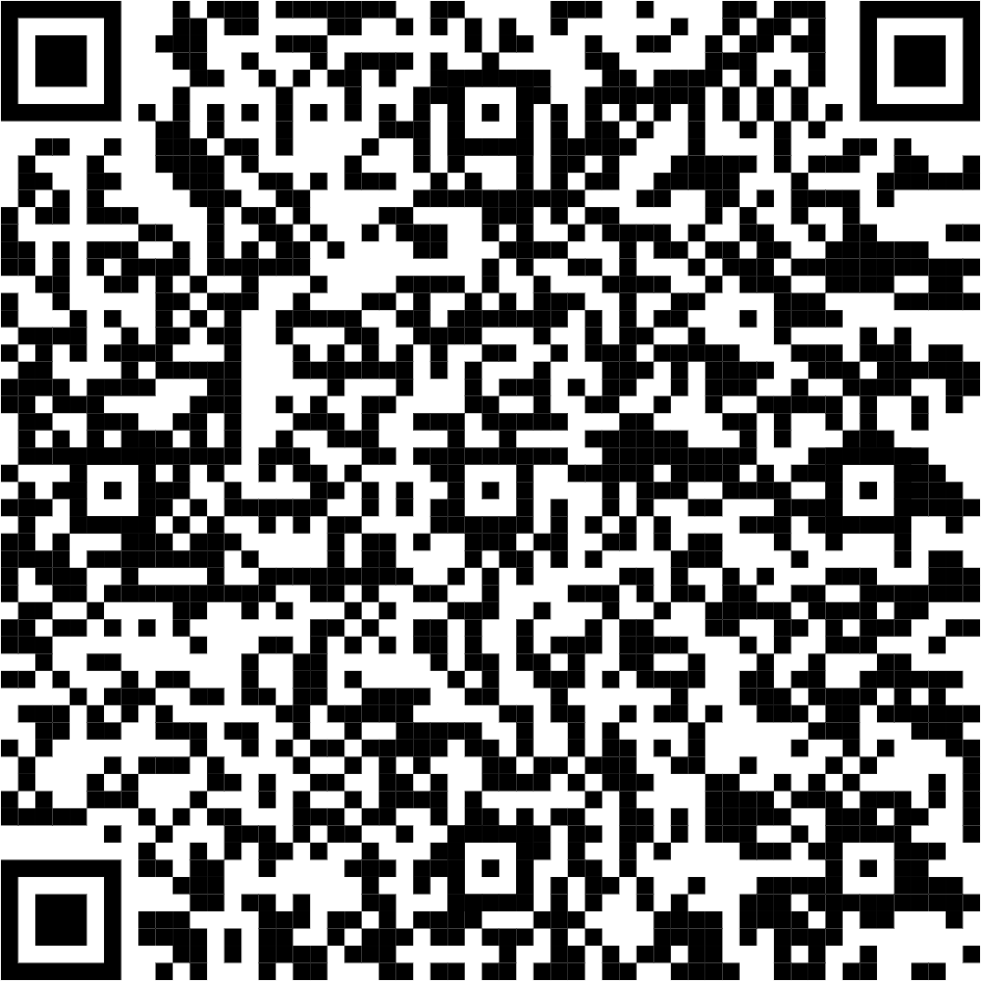

Department of CSE - SVECW | 74

**Importance of an Appendix**

1. Provides Additional Information – Includes details such as data tables, charts, technical explanations, and supporting documents that help the reader understand the topic better.
2. Avoids Overloading the Main Document – Keeps the main text clear and focused while offering extra details in a separate section.
3. Supports Credibility – Strengthens your work by providing references, sources, or background details.
4. Offers Technical or Background Explanations – Useful in technical reports, research papers, or presentations where in-depth details are required but may not fit in the main discussion.
5. Enhances Readability – Helps keep the document concise and easy to read while still making additional information available for those interested.

**9.1 Appendix**

This appendix provides additional technical details, references, and supplementary information related to the project **"Real-Time Anomaly Detection in CCTV Footage Using Deep Learning with Alerting System."** It covers the tools, technologies, and methodologies used to implement the system effectively.

**9.2 Introduction to Anomaly Detection in CCTV Footage**

Anomaly detection refers to identifying unusual patterns or behaviors that do not conform to expected norms. In the context of CCTV footage, it involves detecting suspicious activities such as unauthorized access, unusual movements, or potential threats in real-time.

In this project, we leverage Convolutional Neural Networks (CNNs) for spatial feature extraction and Gated Recurrent Units (GRUs) for temporal sequence modeling. By integrating a real-time alerting system, the project aims to notify security personnel promptly upon detecting anomalies.

**Key Features of the Anomaly Detection System**

1. **Real-Time Processing:**
   * Utilizes pre-trained CNN models for feature extraction and Gated Recurrent Units (GRUs) for temporal pattern analysis.
   * Ensures immediate detection and alert generation to minimize response time.
2. **Alerting System:**
   * Integrates with **email** to notify security teams.
   * Configured to trigger alerts based on the severity of detected anomalies.

Department of CSE - SVECW | 75

1. **Scalability:**
   * Uses a distributed architecture for efficient resource management.
2. **Accuracy and Efficiency:**
   * Achieves high precision and recall rates through continuous training on diverse datasets.

**Convolutional Neural Networks (CNN)**

CNNs are widely used in computer vision tasks due to their ability to detect and learn spatial hierarchies in images. In this project, CNNs play a crucial role in analyzing individual frames of CCTV footage.

Advantages of CNN in This Project:

* Feature Extraction: Extracts spatial features from CCTV frames, such as edges, shapes, and textures.
* Robust to Variations: Handles different lighting conditions, camera angles, and movement effectively.
* Reduced Computational Load: Uses convolutional layers to minimize redundant computations, making real-time processing feasible.

Usage in the Project:

* Each CCTV frame is passed through a CNN model to extract meaningful spatial features.
* The extracted feature maps are then flattened and passed to the GRU model to learn temporal relationships.

Department of CSE - SVECW | 76

**Gated Recurrent Unit (GRU)**

GRU is a variant of Recurrent Neural Networks (RNNs) designed to handle sequential data efficiently while mitigating issues like vanishing gradients. Since video footage is inherently sequential, GRUs are well-suited for analyzing temporal dependencies between frames.

Advantages of GRU in This Project:

* Captures Temporal Patterns: Recognizes anomalies by analyzing changes over consecutive frames.
* Computationally Efficient: Requires fewer parameters than LSTMs, making it faster for real-time applications.
* Handles Long-Term Dependencies: Learns from past frames to detect unusual patterns or behaviors.

Usage in the Project:

* The CNN-extracted feature vectors are fed into a GRU network.
* The GRU processes sequential features over multiple frames to determine if an anomaly is present.
* The final layer classifies the scene as either normal or anomalous based on the learned patterns.

**Implementation Workflow**

1. **Frame Extraction:**
   * Extract frames from the CCTV footage at a fixed interval.
2. **Feature Extraction Using CNN:**
   * Apply convolutional layers to extract important spatial features.
   * Flatten the feature maps and pass them to the GRU network.
3. **Temporal Analysis Using GRU:**
   * Process sequential frame features to learn motion patterns.
   * Detect anomalies based on irregular movements.
4. **Anomaly Detection & Alerting:**
   * If an anomaly is detected, trigger an alert system

Department of CSE - SVECW | 77

**9.4 Introduction to the Alerting System Using SMTP**

In the context of real-time anomaly detection in CCTV footage, an alerting system is essential for promptly notifying relevant authorities or users when unusual activities are detected. For this purpose, the Simple Mail Transfer Protocol (SMTP) is integrated into the system to send automated email alerts instantly. SMTP is a reliable protocol widely used for transmitting emails over the internet, ensuring that notifications reach recipients quickly and efficiently.

**Why SMTP for the Alerting System:**

1. **Reliability:**
   * SMTP is a well-established protocol known for its dependable email delivery capabilities, making it a trusted choice for real-time alert systems.
2. **Speed:**
   * Ensures rapid transmission of alerts, which is crucial in scenarios where immediate action is required.
3. **Integration:**
   * Can be easily integrated with Python using libraries like smtplib, allowing seamless automation of email notifications when anomalies are detected.
4. **Security:**
   * Supports authentication and encryption mechanisms (such as SSL/TLS) to safeguard sensitive information within email alerts.
5. **Customizability:**
   * Allows customization of email content, including subject lines, message bodies, and attachments, to convey detailed information about detected anomalies.

Department of CSE - SVECW | 78